RCB - IPL Strategy

**SUHAS J**

**OBJECTIVE OBSERVATIONS**

1. The IPL dataset consists of approximately 20 tables, with ball_by_ball serving as the primary source of match-level insights. The data types for the columns in this table are outlined below.

**Query: Result:**

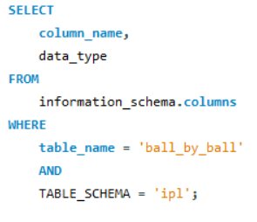

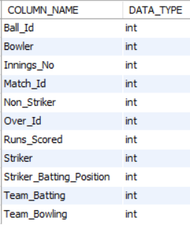

From the above result we can see that all the columns in ball_by_ball table are of **‘int’(Integer)** datatype which represents numerical values.

1. Run accumulation was a key driver of team performance. This analysis explores Royal Challengers Bengaluru’s scoring patterns during their season

**Approach:**

* **Tables:** Performed joins across the Matches, ball_by_ball, Season, and extra_runs tables to extract the desired outcome.
* **Filtering records:** Filtered records for ‘Royal Challengers Bengaluru’ team and for the required season.
* **Strategy:** Applied appropriate aggregation functions on runs_scored column to derive the expected results from the dataset.
* **Final Result:** Derived team-specific insights by grouping data across season and year attributes.

**Query:**

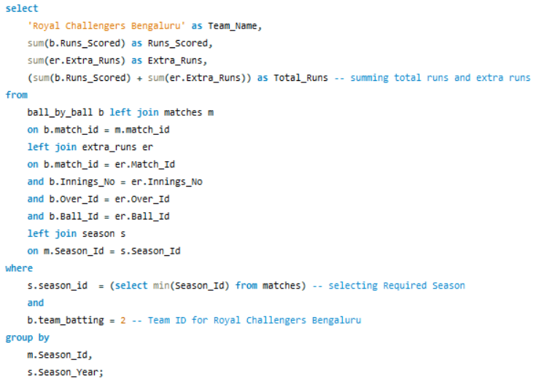

**Result:**

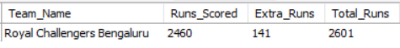

Royal Challengers Bengaluru recorded **2,601** runs in total, with 2,460 from the team and 141 coming through extras.

1. Understanding the age distribution of players offers insight into experience levels within the squad. This segment focuses on identifying players older than 25 during the 2014 season

**Approach:**

* **Tables:** Performed joins across the Matches, player_match, Season, and player tables to extract the desired outcome.
* **Filtering records:** Filtered records for the required season and Player age.
* **Strategy:** Applied appropriate aggregation functions on player_id column to derive the expected results from the dataset.
* **Final Result:** Derived count of players.

**Query:**

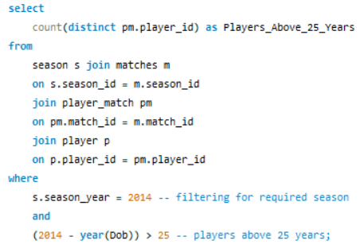

**Result:**



The 2014 IPL season featured **102** **players** aged over 25, offering a glimpse into the age distribution and veteran influence within the league.

1. Evaluating Royal Challengers Bengaluru’s performance during the 2013 season begins with a look at their match victories

**Approach:**

* **Table:** Performed joins across the Matches, Team and Season tables to extract the desired outcome.
* **Filtering records:** Filtered records for the required year and Team.
* **Strategy:**
  + **Aggregation:** Applied appropriate aggregation functions required column to derive the expected results from the dataset.
  + **Calculations:** Leveraged CASE WHEN clauses to facilitate smoother data processing and calculation logic.
* **Final Result:** Derived team-specific match victories based on Year.

**Query:**

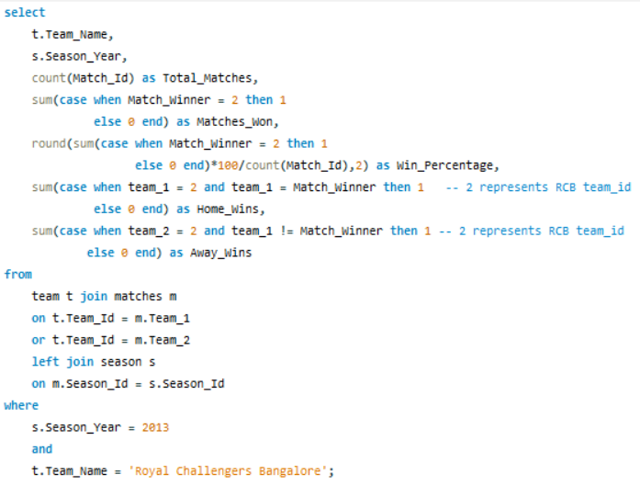

**Result:**



During the **2013** IPL season, Royal Challengers Bengaluru contested 16 matches, securing **9** victories with a win rate of **56.25%**. Notably, **7** of these wins came on home ground, while **2** were achieved in away fixtures.

1. Strike rate is a key indicator of a player's impact, especially in high-paced formats like the IPL. This analysis highlights the top 10 players with the highest strike rates over the last four seasons

**Approach:**

* **Tables:** Performed joins across the Player, Player_Match, ball_by_ball Matches and Season tables to extract the desired outcome.
* **Filtering records:** Data was curated for the previous four IPL seasons with reference to the most recent league edition for contextual accuracy.
* **Strategy:** 
  + Creating a Common Table Expression for ease of calculation.
  + Strike Rate = (Total Runs Scored / Total Balls) * 100
  + To ensure meaningful insights, the analysis includes only players who have faced a minimum of 60 balls across the last four IPL seasons.
  + Players are ranked based on their increasing order of strike rate using the DENSE_RANK () function to handle ties and maintain consistent ordering.
* **Final Result:** Displaying Top 10 Player Name along with the strike rate and their ranking.

**Query:**

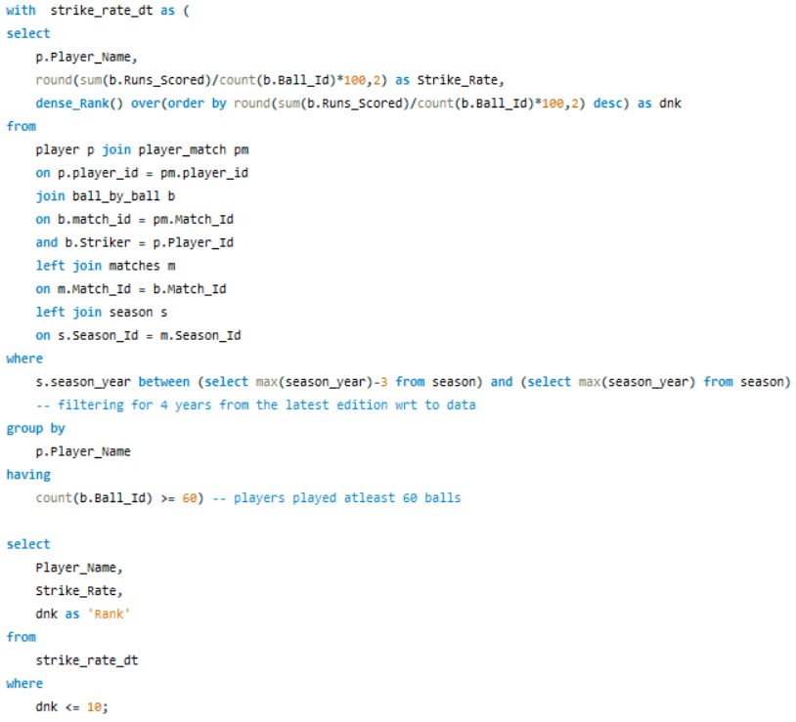

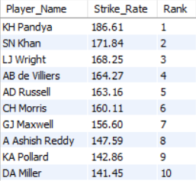**Result:**

Following the evaluation, player names are displayed in conjunction with their strike rates and performance ranks

1. Beyond flashy innings, it's consistency that defines great batsmen. Assessing average runs across all IPL seasons provides a clear view of consistency and scoring reliability. This segment focuses on calculating each batsman's average contribution over the entire tournament history

**Approach:**

* **Tables:** Performed joins across the Player, ball_by_ball and Wicket_taken tables to extract the desired outcome.
* **Statergy:**
  + Average Runs = Total Runs / No. of times out
  + To ensure statistical reliability, the analysis includes only players who have featured in more than 25 matches, filtering out outliers with minimal appearances.
* **Final Result:** Showcasing the results for top-performing batsmen known for consistency in the IPL.

**Query:**

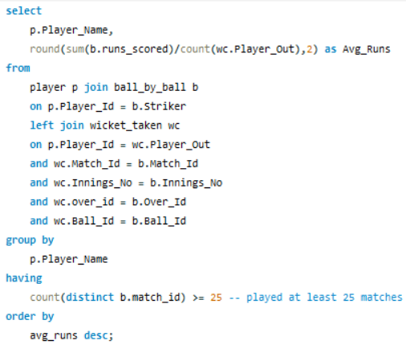

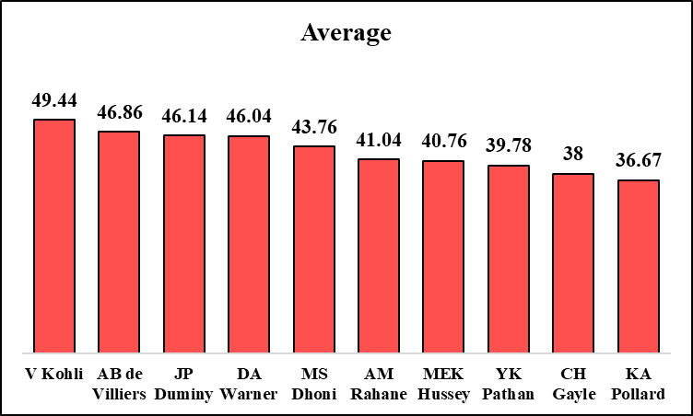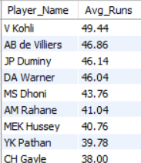**Result:**

Following the evaluation, players name are displayed in conjunction with their average runs.

1. While economy rates show control, average wicket tallies reflect impact. This analysis reveals how frequently bowlers have struck across all IPL seasons

**Approach:**

* **Join Tables:** Performed joins across the Player, ball_by_ball, Matches, Wicket_taken and Out_Type tables to extract the desired outcome.
* **Filtering Records:** Applied filtering to exclude non-standard dismissals including 'run out', 'retired hurt', 'hit wicket', and 'obstructing the field' for accurate wicket aggregation for each player.
* **Statergy:**
  + Separate analysis is made for the calculation of the average wickets taken,
    - Match-wise Analysis
    - Season wise Analysis
  + For Match-Wise Analysis
    - Average wickets = Total Wickets taken / Total Matches Played.
    - To ensure statistical reliability, the analysis includes only players who have featured in more than 10 matches, filtering out outliers with minimal appearances.
  + For Season -Wise Analysis
    - Average wickets = Total Wickets taken / Total Season Played.
    - To ensure statistical reliability, the analysis includes only players who have featured in more than 2 seasons, filtering out outliers with minimal appearances.
* **Final Result:** Showcasing the results for top-performing bowler known for wickets in the IPL in case of match and season wise separately.

**Query: Match-wise Analysis**

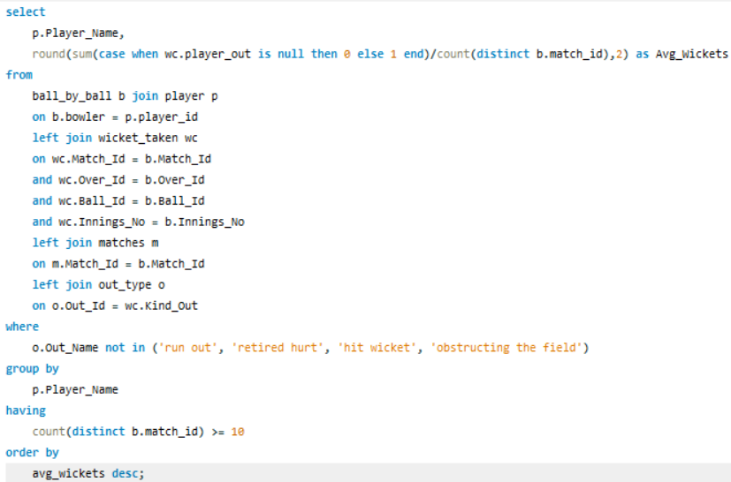

**Result:**

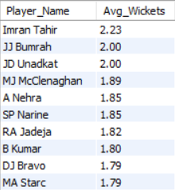

**Query: Season-wise Analysis**

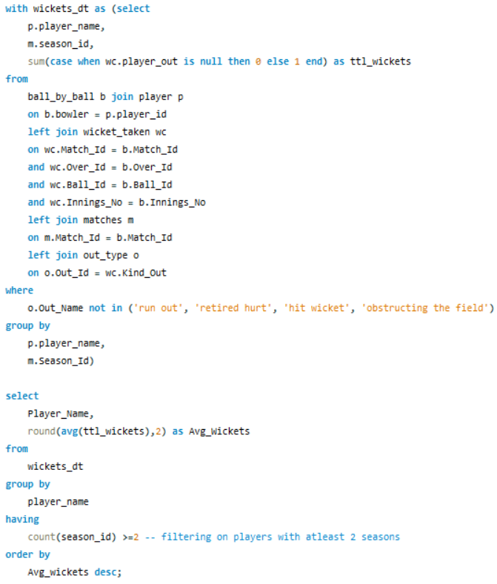

**Result:**

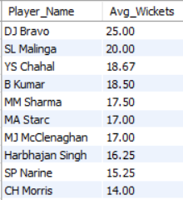

1. To spotlight true all-round impact, this analysis lists players who surpass the overall average in both batting and bowling scoring more runs and claiming more wickets than the league norm.

**Approach:**

* **Tables:** Performed joins across the Player, ball_by_ball, Wicket_taken tables to extract the desired outcome.
* **Filtering Records:** Players with below-average runs scored and wickets taken were excluded to focus on consistent dual-discipline performers
* **Strategy:** 
  + Creating CTE for easy of calculation
    - Average runs for each player
    - Wickets taken by each player
    - Overall Average of runs and wickets of all the players
    - Final result set.
  + Player Average Runs = Total Runs scored / Number times out
  + Player wickets taken = total wickets taken.
* **Final Result:** Displaying the records for players with average runs and wickets taken greater than the overall average.

**Query:**

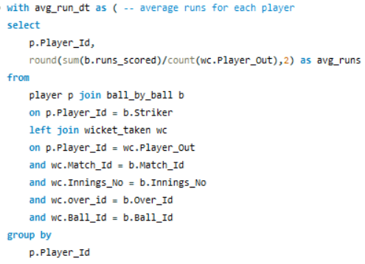 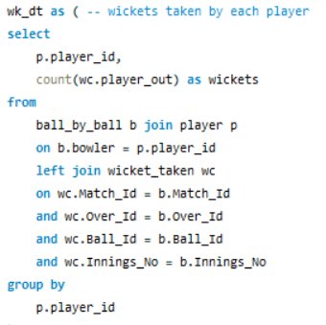

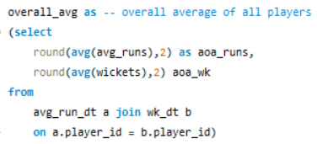 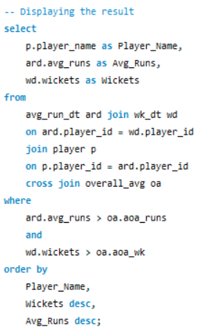

**Result:**

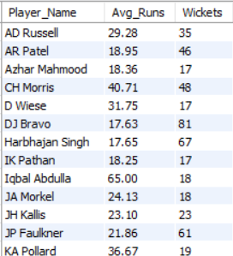

The resulting list showcases a select group of players who embody versatility and consistency, outperforming peers in both scoring runs and taking wickets. These individuals not only anchor innings with the bat but also create breakthroughs with the ball, reinforcing their value as dependable all-round performers in the IPL ecosystem.

1. To understand RCB’s performance across different grounds, we construct a venue-wise record table that outlines the number of wins and losses at each individual stadium.

**Approach:**

* **Tables:** Performed joins across the Matches, Venue and team tables to extract the desired outcome.
* **Filtering records:** Filtering the records for only Royal Challengers Bengaluru team.
* **Statergy:**
  + Creating table ‘rcb_record’ with necessary columns and respective Datatypes
    - Venue Name, Total matches played, Wins, Loss, Win percentage and Loss percentage
  + Grouped relevant match statistics based on venue, applying conditional logic through CASE WHEN statements to refine metric calculations
  + Inserting the queries tool to the table created in the first step.

**Query:**

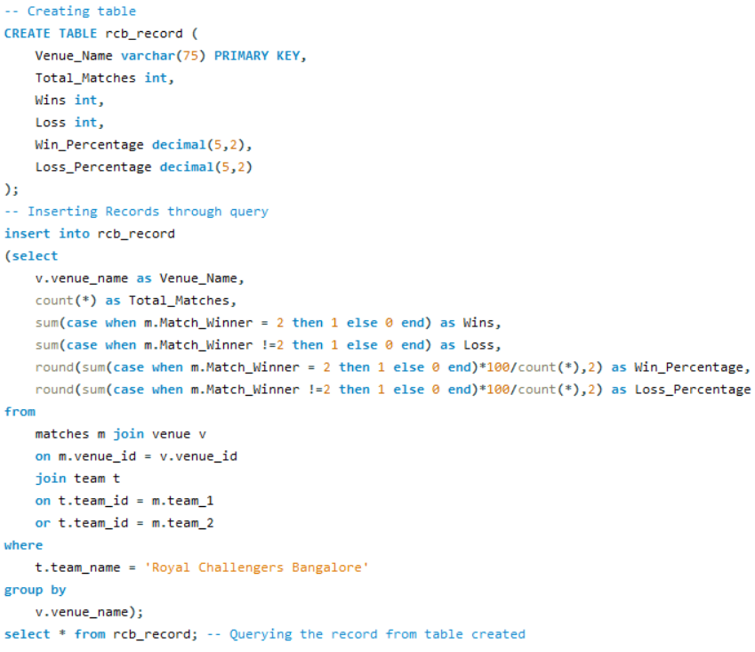

**Result:**

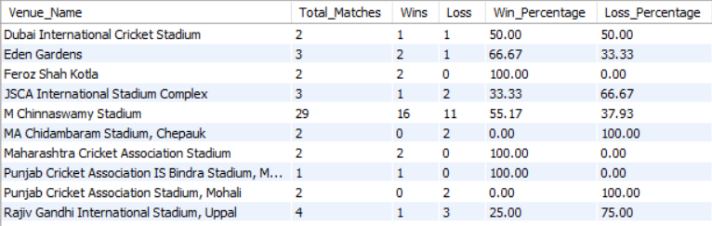

1. Bowling style plays a pivotal role in a player's wicket-taking ability, influencing factors like pitch behaviour, match conditions, and batsman vulnerability. This analysis explores how different bowling styles like pace, spin, or variations which impact wicket counts across IPL seasons

**Approach:**

* **Tables:** Performed joins across the ball_by_ball, player, wicket_taken, bowling_style and out_type tables to extract the desired outcome.
* **Filtering Records:** Applied filtering to exclude non-standard dismissals including 'run out', 'retired hurt', 'hit wicket', and 'obstructing the field' for accurate wicket aggregation for each player.
* **Strategy:** Calculatingthe total wickets and aggregating it by different Bowling Style.
* **Final Result:** Displaying the bowling style along with the wickets taken.

**Query: Result:**

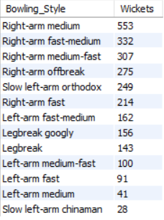 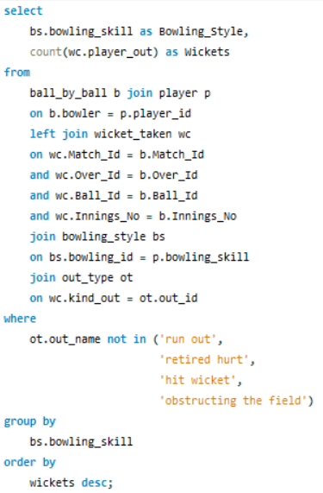

1. Consistency and growth are key markers of team success in the IPL. This query tracks annual shifts in core metrics of runs scored and wickets claimed by **RCB** to determine whether the team improved compared to its prior season.

**Approach:**

* **Join Tables:** Performed joins across the team, matches, season, ball_by_ball, wicket_taken and custom created CTE tables to extract the desired outcome.
* **Filtering Records:** As the focus of this analysis is on a specific team, we apply filters to isolate records pertaining to Royal Challengers Bangalore
* **Strategy:** 
  + Creating CTE for easy of calculation
    - Runs Scored by the team in all seasons.
    - Wickets taken by the team in all seasons.
    - Combining Runs scored and wickets taken for each season.
  + Seasonal performance metrics were aggregated to summarize the team's cumulative runs and wickets across each IPL season.
  + Applied a self-join on the season-wise performance dataset to compare each year’s results against its preceding season.
  + Utilized CASE WHEN logic to evaluate year-on-year changes and classify each season's performance relative to the previous year
* **Final Result:** Season-wise data presentation reveals the team’s evolving performance trajectory over the years in terms of runs scored and wickets taken.

**Query:**

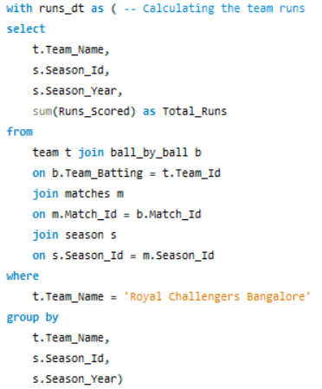 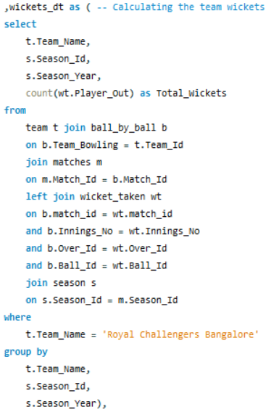

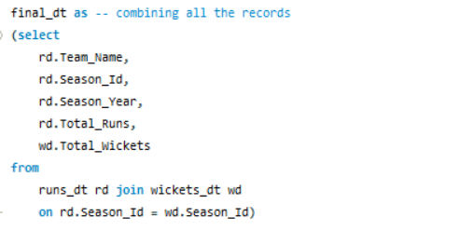

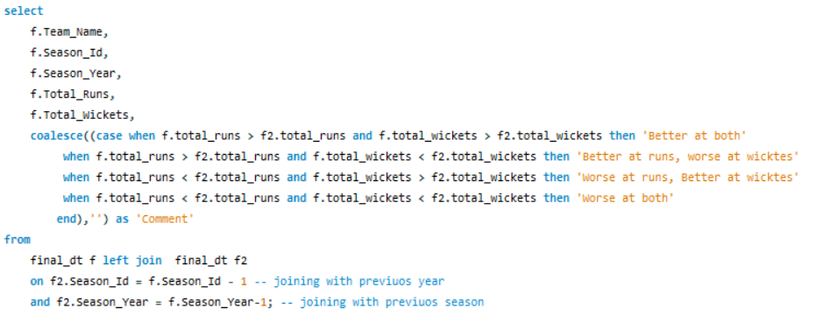

**Result:**

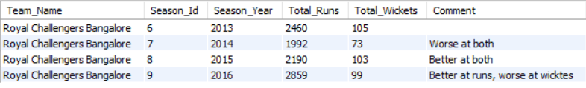

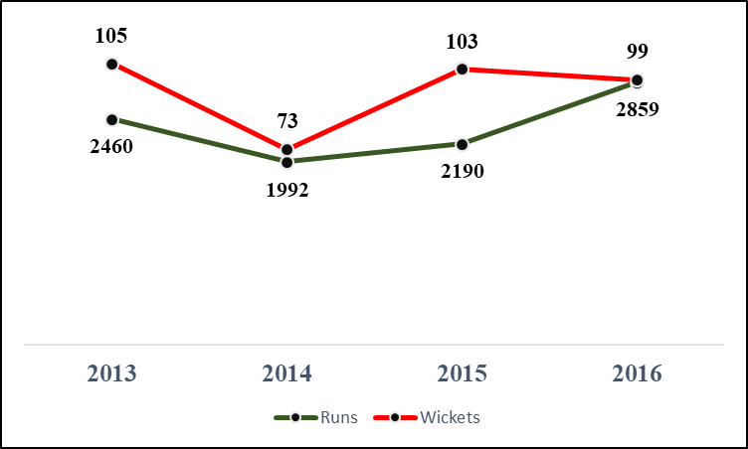

By comparing season-wise aggregates of runs scored and wickets taken, we established a clear status indicator that reflects whether the team's performance improved relative to the previous year. This classification helps highlight trends in both batting and bowling effectiveness across IPL seasons offering a data-driven view of RCB’s growth, consistency, or challenges over time. Such insights are valuable for evaluating strategic impact, squad evolution, and areas of improvement.

1. This segment introduces refined performance indicators that quantify RCB’s strategic execution across IPL seasons. From phase-wise scoring efficiency to wicket distribution trends, each KPI provides a data-driven lens into the tactical dynamics influencing match outcomes.

**Approach:**

To align with the analysis objectives, the KPIs have been segmented into four distinct categories, allowing for a focused evaluation of each strategic dimension individually. They are,

* **Team Performance KPI** – This focuses on the team's strategic outcomes, including the number of tosses won, accuracy in converting toss decisions into wins, and the total matches won along with their percentage share.
* **Scoring Composition Summary KPI** – This KPI set captures the team’s scoring performance, analysing the proportion of boundary deliveries, frequency of dot balls, and share of runs accumulated through running between the wickets (1s, 2s, and 3s).
* **Batting performance KPI** – This analysis segments the match into three distinct over types those are Power Play, Middle Overs, and Slog Overs. For each phase, key batting metrics such as average run rate, dot ball percentage, boundary ball percentage, batting strike rate, run contribution percentage, and wickets lost percentage are aggregated to quantify performance.
* **Bowling Performance KPI** – This analysis segments the match into three distinct over types those are Power Play, Middle Overs, and Slog Overs. For each phase, key bowling metrics such as average economy, dot ball percentage, boundary ball percentage, bowling strike rate, run conceded percentage, and wickets taken percentage are aggregated to quantify performance.

**Query and Result:**

**Team Performance KPI**

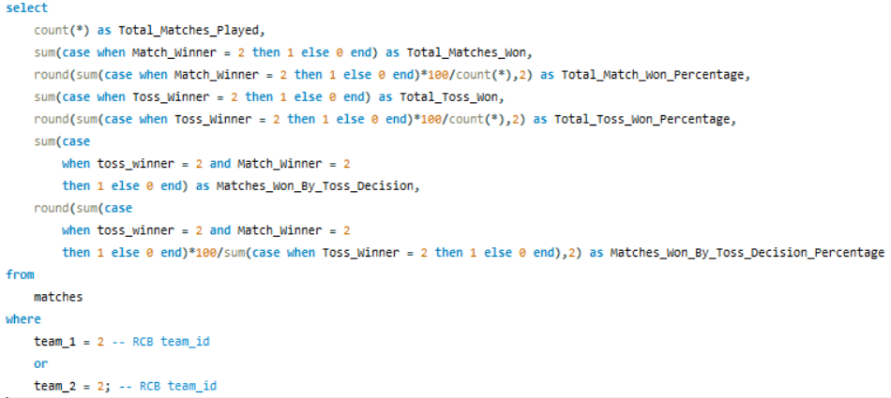



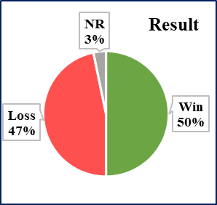 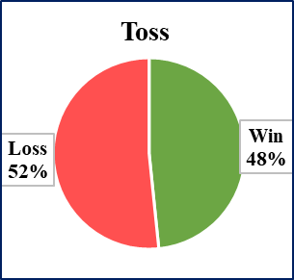

**Team Scoring Composition Summary KPI**

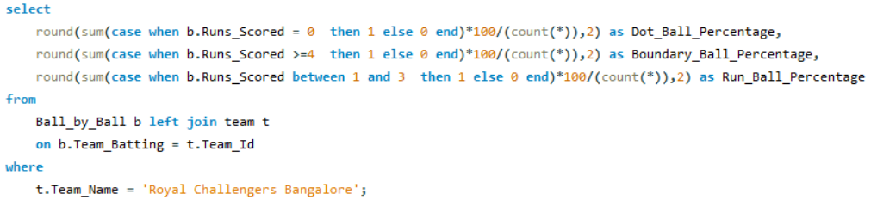

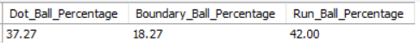

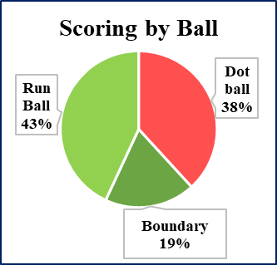

**Batting Performance KPI:**

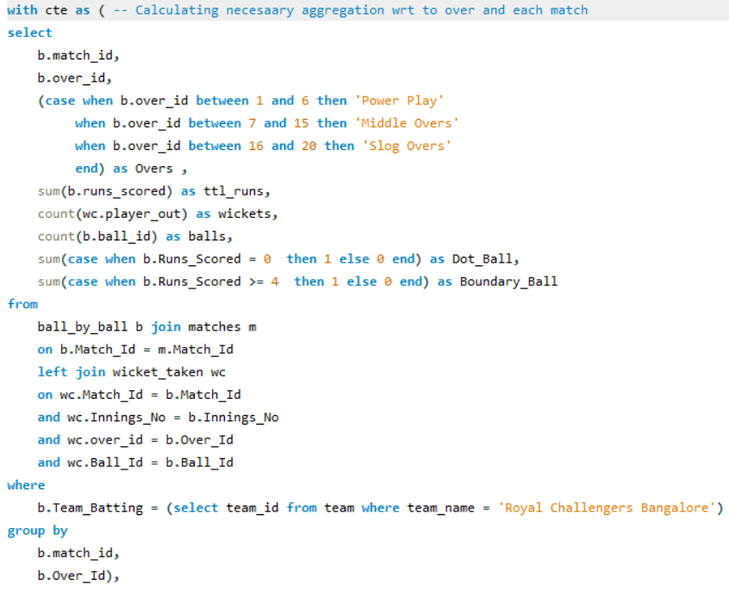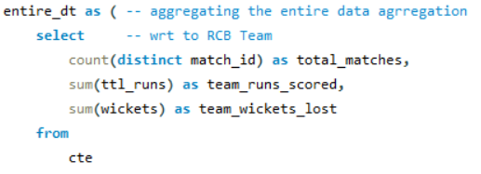

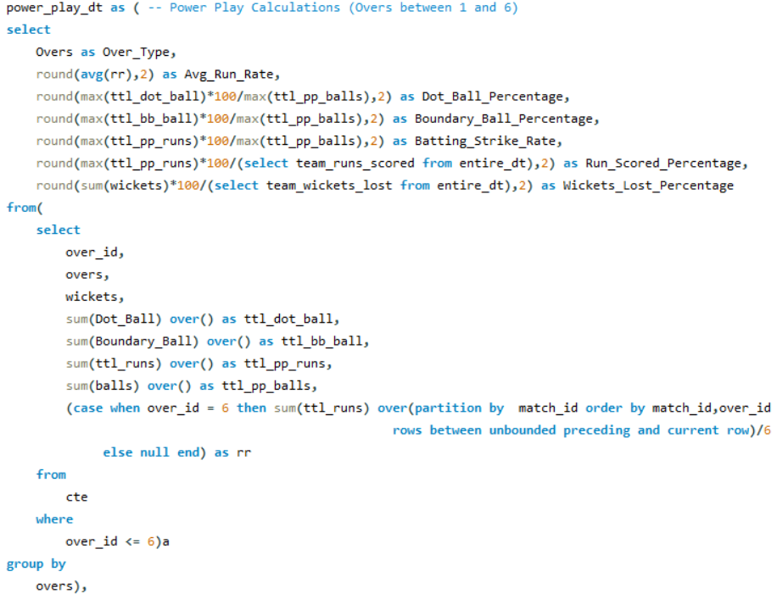

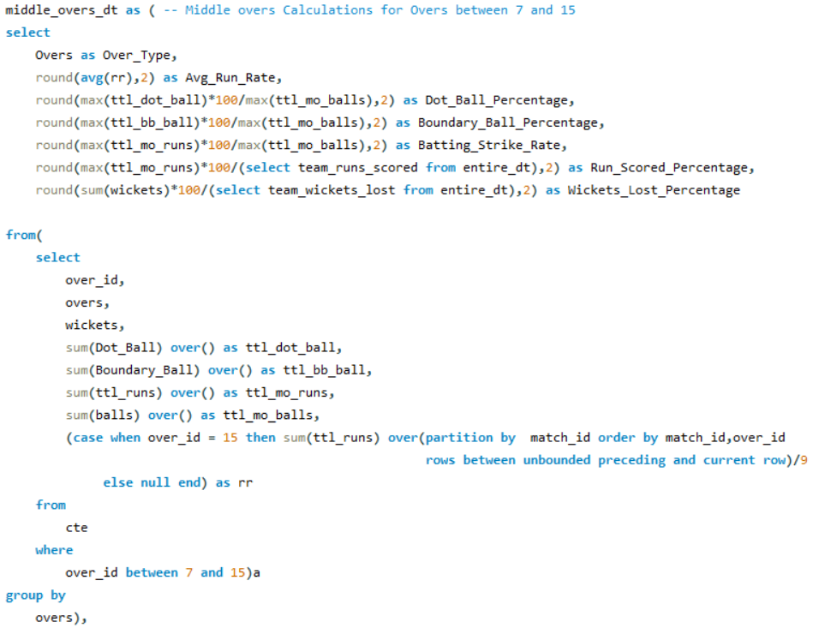

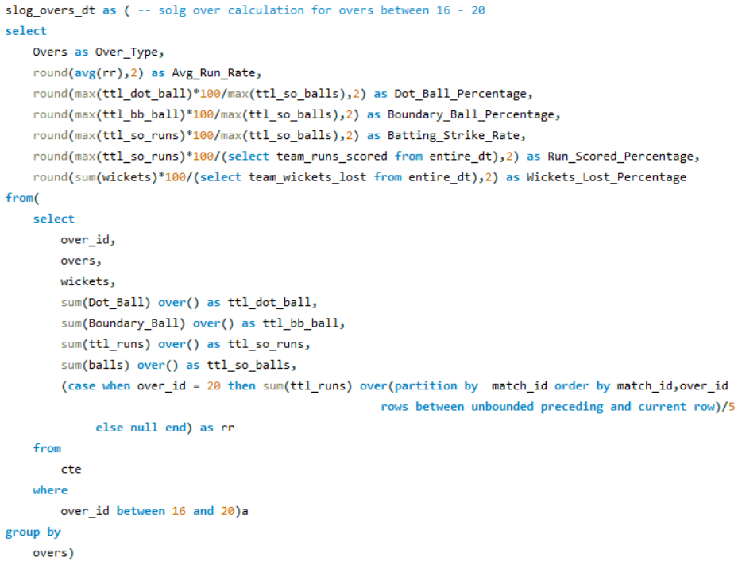

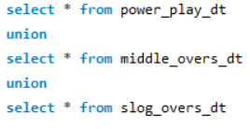



**Bowling Performance KPI:**

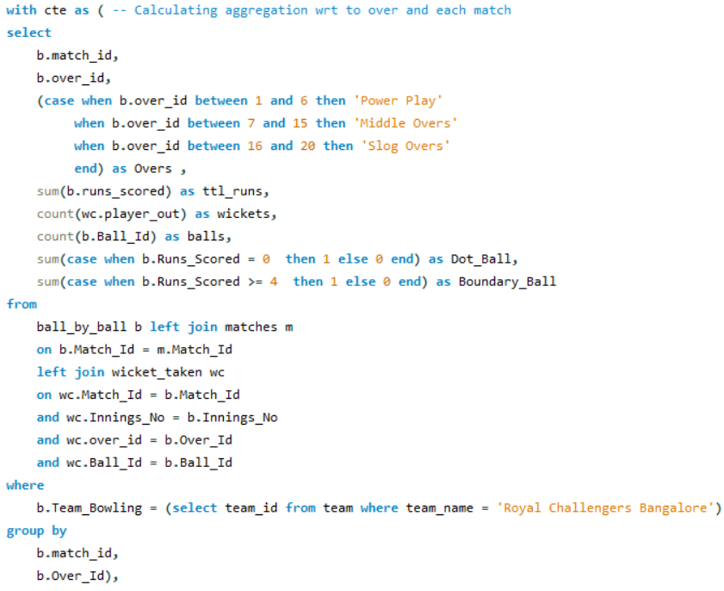

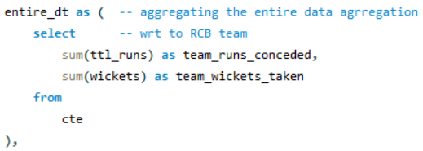

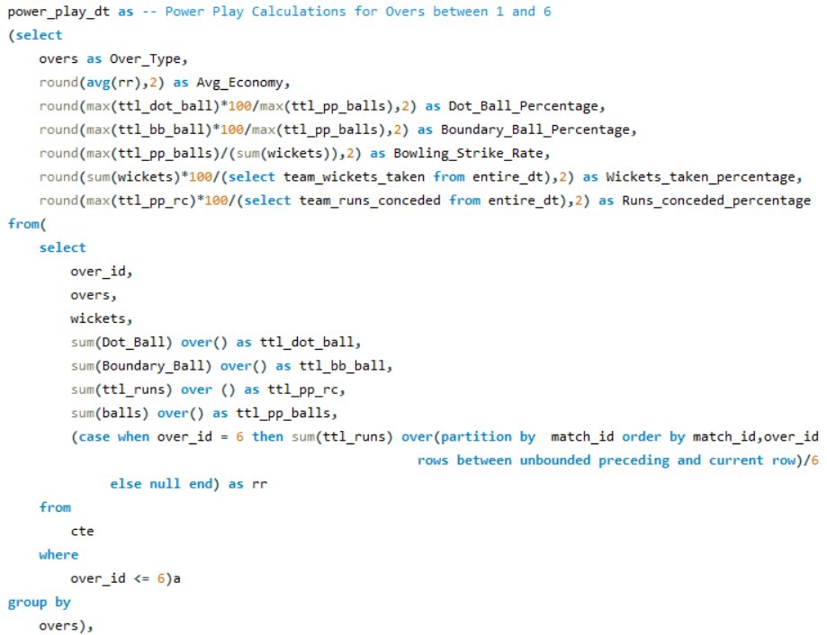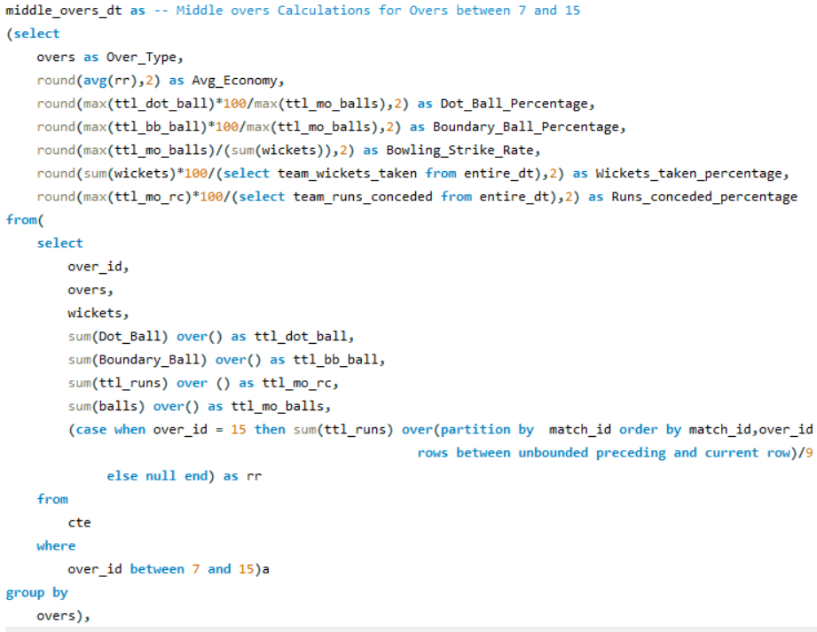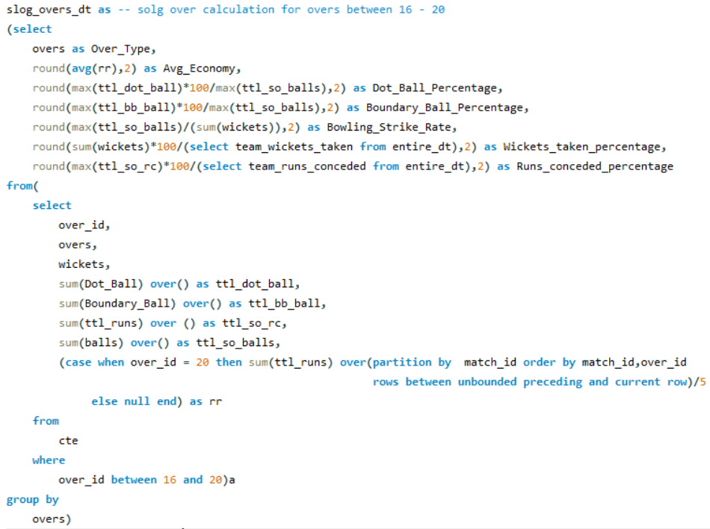 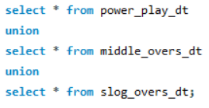



1. This analysis computes the average number of wickets taken by each bowler at every venue, segmented by gender. By aggregating match-level data and applying ranking logic, we identify performance variations and evaluate gender-based bowling impact across locations.

**Approach:**

* **Tables:** Performed joins across the player, ball_by_ball, wicket_taken, matches, out_type, venue and custom created CTE tables to extract the desired outcome.
* **Filtering Records:** Applied filtering to exclude non-standard dismissals including 'run out', 'retired hurt', 'hit wicket', and 'obstructing the field' for accurate wicket aggregation for each player.
* **Strategy:**
  + Average Wickets in Each Ground = Total Wickets / Matches played in each ground
  + Aggregating the value on Player name and Venue name.
  + Using DENSE RANK to order the average wickets of a player in different venues played.
* **Final Result:** Display the average number of wickets taken by each player at every venue, along with their corresponding rankings.

**Query:**

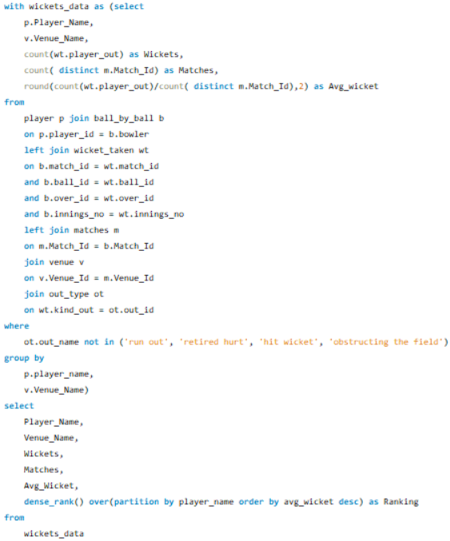

**Result:** 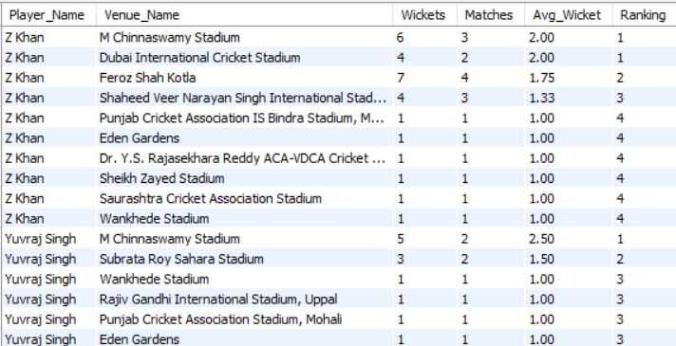

1. Consistency in cricket performance demands not only skill but also repeatable execution across varied match conditions and opposition.

This analysis dives deep into historical performance data to identify the most consistent contributors in two key roles: **batsmen** and **bowlers**.

**Approach:**

* **Tables:** Performed joins across the player, ball_by_ball, matches, Seasons and custom created CTE tables to extract the desired outcome.
* **Strategy:**
  + The top 5 consistent batsmen are identified by computing the average number of runs they scored per season, derived by dividing their total career runs by the number of seasons played.
  + The top 5 consistent bowler are identified by computing,
    - **Average wickets =** Total wickets / Number of seasons played.
    - **Average Economy =** Total Runs conceded/ Number of overs bowled.
  + Aggregating the value on Player name and Seasons played.
  + To ensure statistical reliability, the analysis includes only players who have featured in at least 3 seasons, filtering out outliers with minimal appearances.
* **Final Result:** Display the Top 5 batsmen and bowlers with their remarkable performances.

**Query:**

Top 5 Consistent Batsmen: Top 5 Consistent Bowlers:

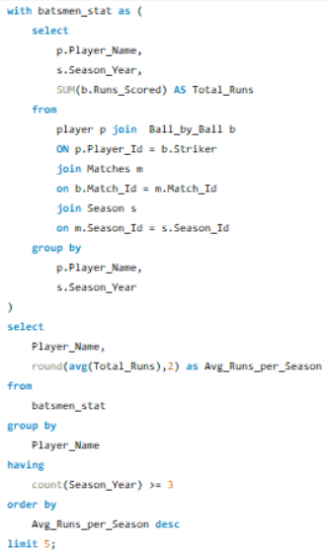 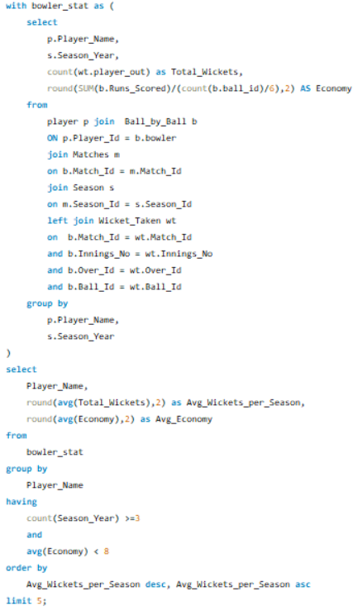

**Result:**

**Top 5 Consistent Batsmen:**

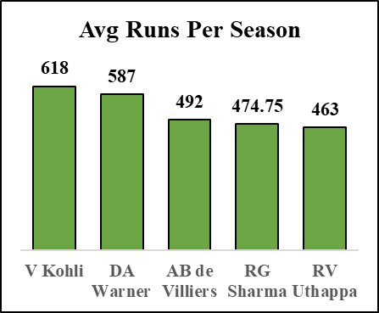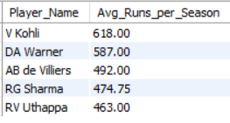

**Top 5 Consistent Bowlers:**

**Average wickets Average Economy**

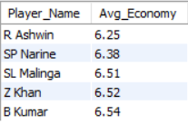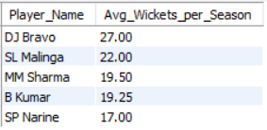

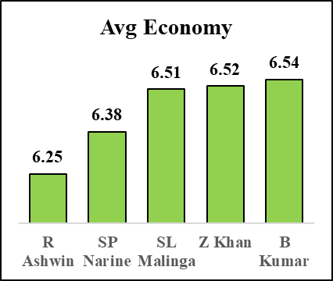

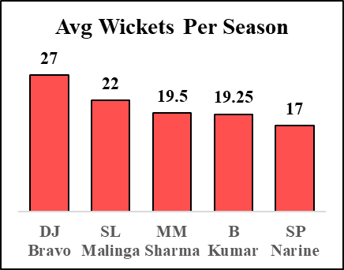

1. Players often exhibit statistically significant performance shifts based on venue and pitch type. This analysis cross-references player metrics with environmental variables to reveal condition-specific outperformance patterns.

This analysis dives deep into historical performance data to identify the most contributors in two key roles: **batsmen** and **bowlers**.

**Approach:**

* **Tables:** Performed joins across the player, ball_by_ball, matches, Wicket_taken and Venue and custom CTE tables to extract the desired outcome.
* **Strategy:**

Top-performing players in specific venues or conditions are identified by analysing their venue wise metrics of total runs, average runs, and strike rate for each batsman, and total wickets taken along with economy rate for each bowler.

* + Aggregating the value on Player name on each venue.
  + Players with favourite venues based on their runs scored are selected using the DENSE_RANK () function to handle ties and maintain consistent ordering.
  + To ensure statistical reliability, the analysis includes only players who have played more than 120 balls for batsmen and bowled more than 60 bowls for bowlers, filtering out outliers with minimal appearances.
* **Final Result:** Display the Top performers at specific venue.

**Query: Batsmen**

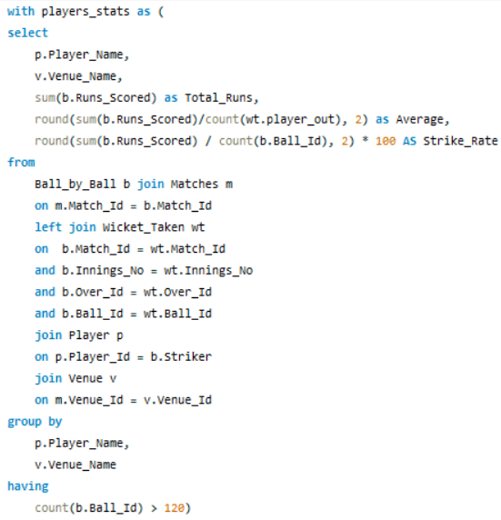 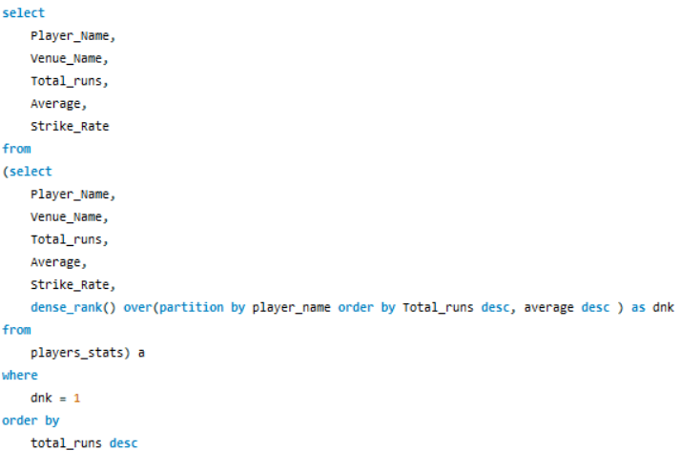

**Result:**

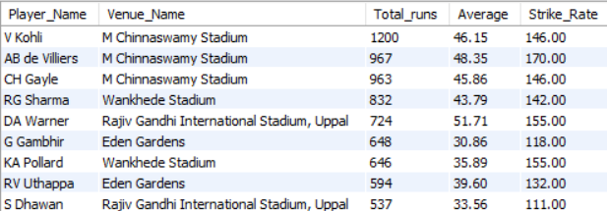

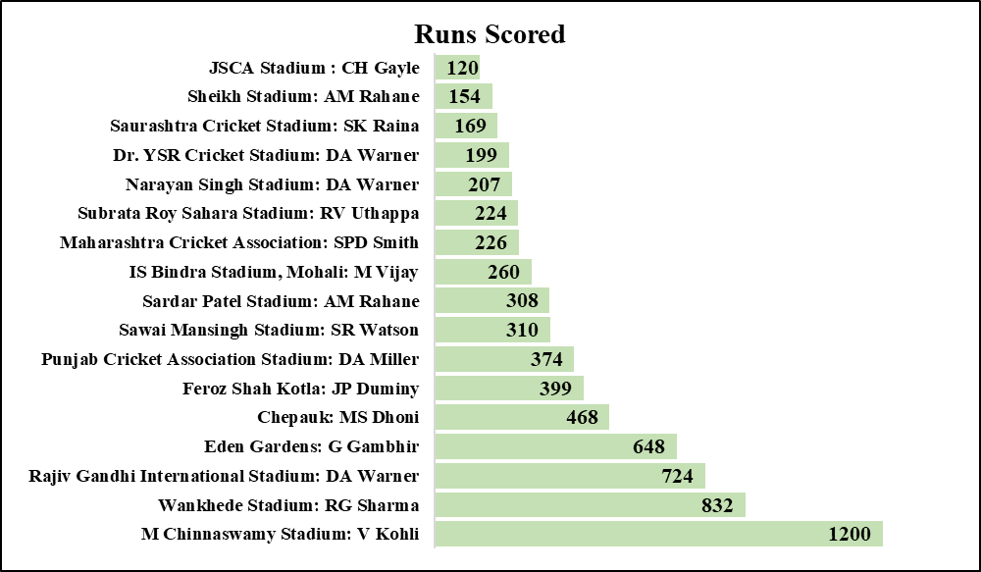

The above chart presents the leading run scorer for every venue

**Query: Bowlers**

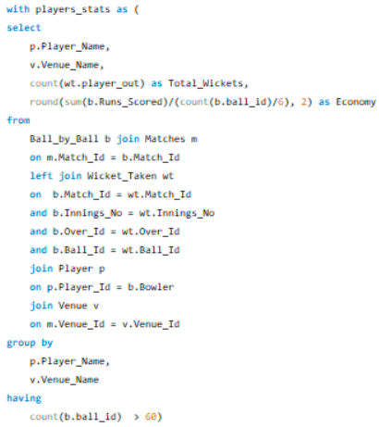 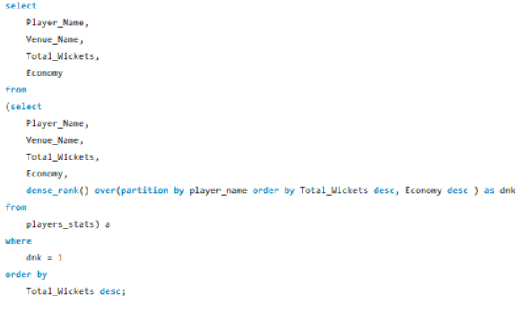

**Result:**

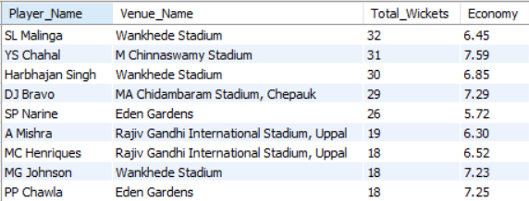

The below chart presents the leading wicket taker for every venue

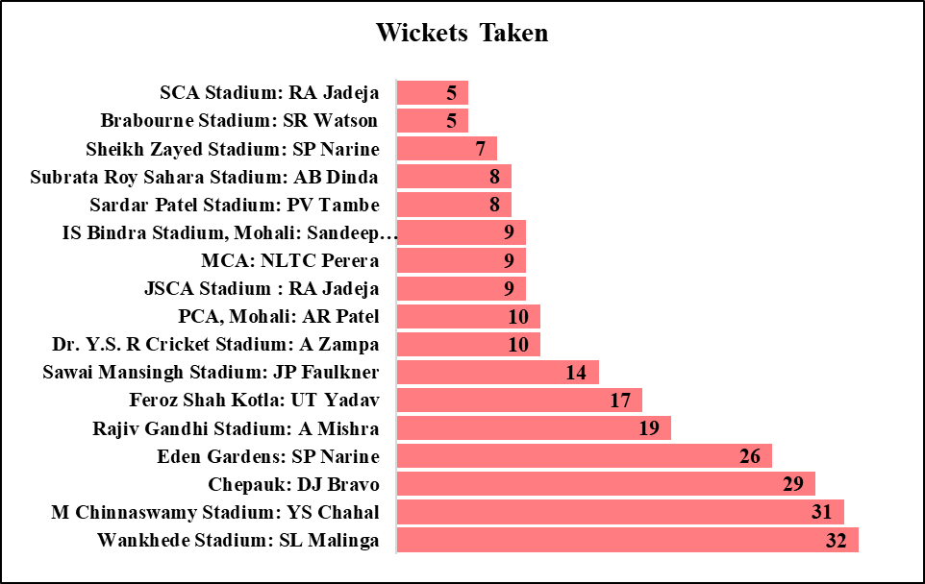

**SUBJECTIVE OBSERVATIONS**

1. The toss isn't just a formality—it can shape match outcomes based on pitch behaviour, dew factors, and scoring trends. This analysis explores how the decision to bat or bowl first correlates with win rates across venues

**Approach:**

* **Tables:** Performed joins across the matches and Toss Decisions to extract the desired outcome.
* **Strategy:**
  + Calculating favourite toss decision and percentage of win for each toss type.
  + Calculating venue wise decision and its result
* **Final Result:** Display the venue wise decision and the result of match.

**Query: Toss Decision**

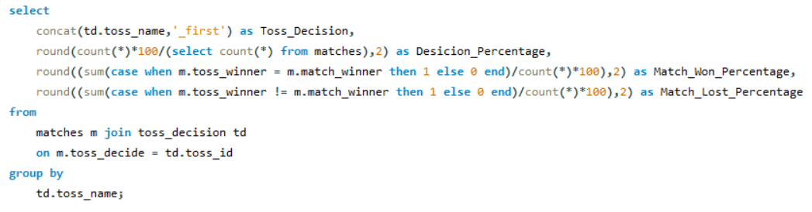

**Result:**

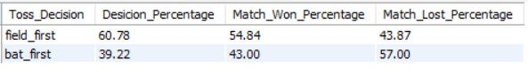

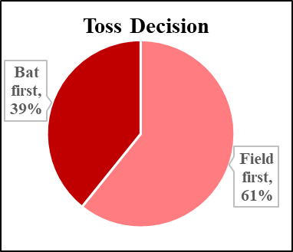 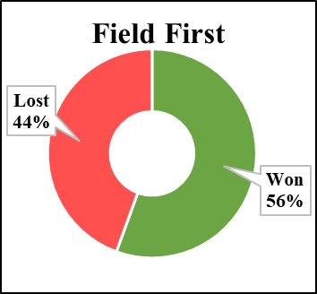 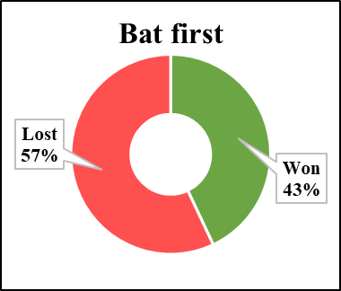

The analysis reveals a clear preference among toss winners to **field first**, with **over 60%** opting to **bowl**. Notably, this decision translates into success, as more than **56%** of those matches **result in victory** for the team that bowled first.

**Query: Venue wise Decision**

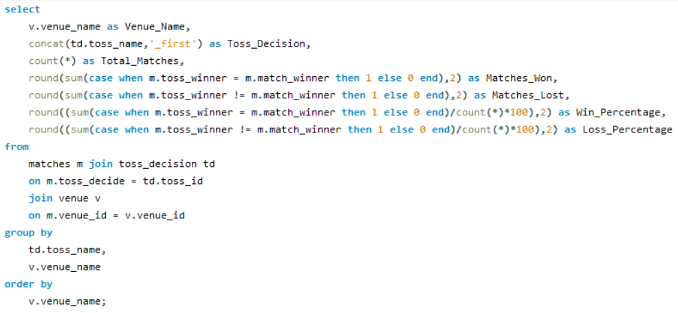

**Result**

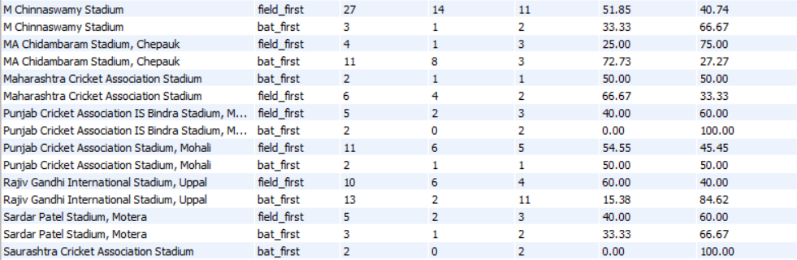

The analysis highlights clear venue-based trends in match outcomes some stadiums consistently favour teams that bat first, while others are more suited for chasing. This distinction plays a crucial role in toss decisions and match planning.

|  |  |
| --- | --- |
| **Bat First suitable Venue** | **Bowl First Suitable Venue** |
| M. A. Chidambaram Stadium (Chepauk) | Eden Gardens |
| Wankhede Stadium | Feroz Shah Kotla |
| Subrata Roy Sahara Stadium | JSCA International Stadium Complex |
| Himachal Pradesh Cricket Association Stadium | M. Chinnaswamy Stadium |
| Sardar Patel Stadium, Motera | Maharashtra Cricket Association Stadium |
| Punjab Cricket Association IS Bindra Stadium, Mohali | Rajiv Gandhi International Cricket Stadium, Uppal |

1. Building a winning squad isn’t just about picking stars, it’s about assembling the right blend of specialists who fit the match scenario, venue conditions, and team dynamics. This selection framework identifies top-performing **batsmen**, **bowlers**, and **all-rounders** who bring consistent value and tactical flexibility.

**Approach:**

* **Tables:** Performed joins across the Player, Ball_by_ball and wicket_taken to extract the desired outcome.
* **Strategy:**
  + The player selection criteria are structured across three distinct categories: batsmen, bowlers, and all-rounders. The criteria for choosing the players are:
    - **Batsmen**: Must have an average score above 25, a strike rate exceeding 130, and should have played a minimum of 30 matches.
    - **Bowlers**: Should maintain an economy rate below 8, have taken at least 30 wickets, and featured in 20 or more games.
    - **All-rounders**: Required to have played at least 20 matches, with a batting average above the dataset’s overall batsmen average and a wicket count higher than the overall bowling average.
* **Final Result:** Showcasing potential player picks best aligned with team needs for the upcoming auction.

**Query: Good Batsmen with experience, Strike Rate and Average Runs**

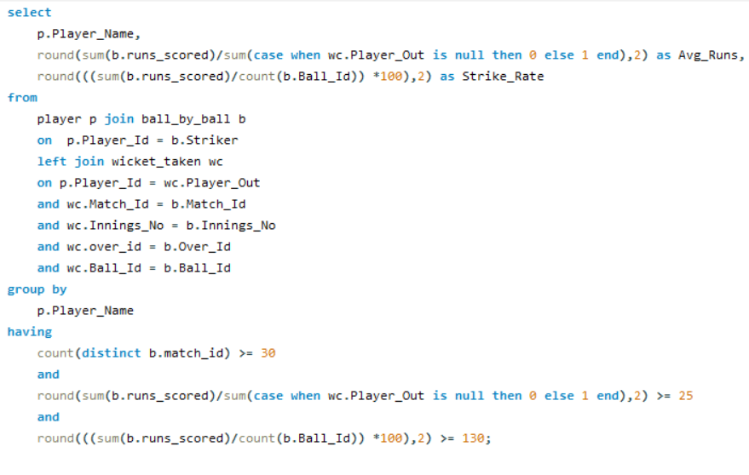

**Result:**

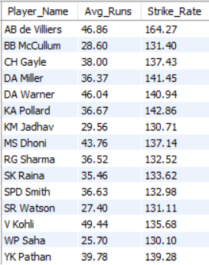

**Query: Good Bowlers with experience, Wickets and economy**

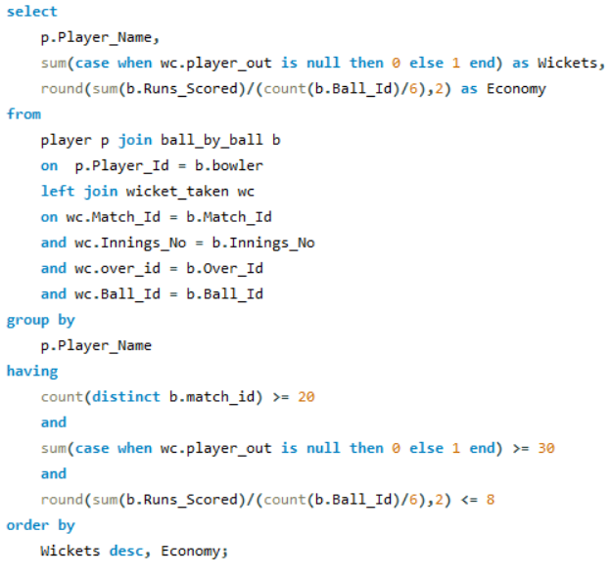

**Result:**

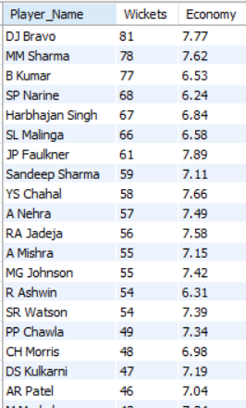

**Query: Good All-rounders with experience, Wickets and runs**

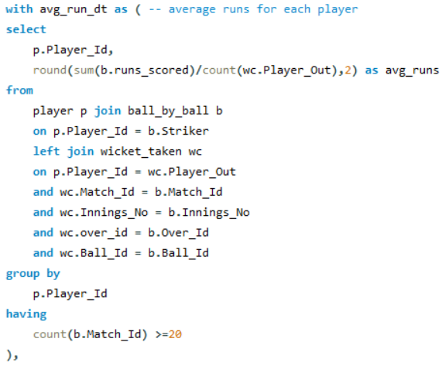 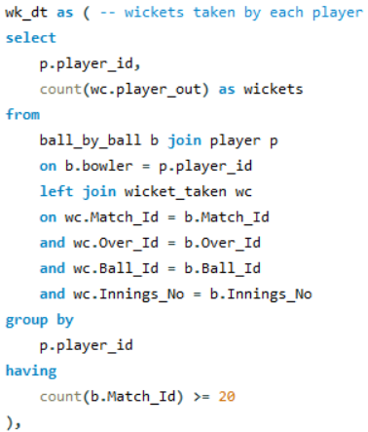

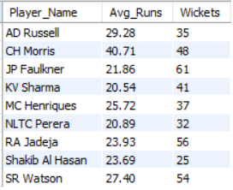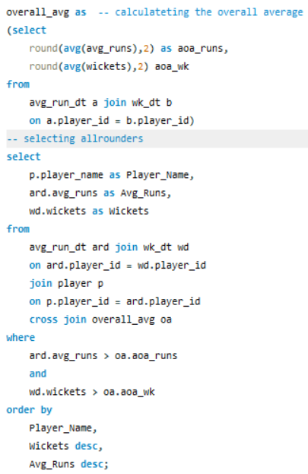

**Result**

Selecting these recommended players is aimed at enhancing team balance and elevating overall performance which is a critical factor in building a winning side for the tournament.

1. Choosing the right players goes far beyond reputation or recent form. It’s a calculated exercise rooted in evaluating multiple performance and contextual parameters that influence team dynamics and match outcomes.

**Approach:**

* **Tables:** Performed joins across the Player, Ball_by_ball, wicket_taken, Matches and custom CTE to extract the desired outcome.
* **Strategy:**
  + The selection parameters are grouped into two categories: batting metrics and bowling metrics. Filtering records for latest season (2016) for better analysis.
* **Final Result:** Showcasing potential parameter to consider which is aligned with team needs for the upcoming auction.

**Query: Batting parameter**

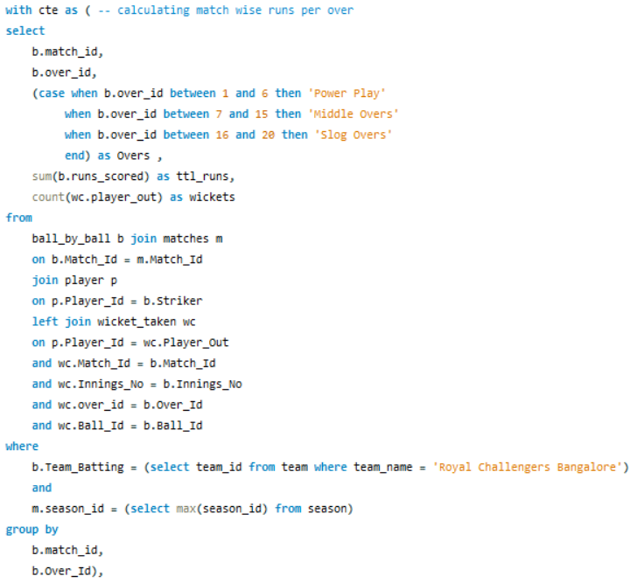

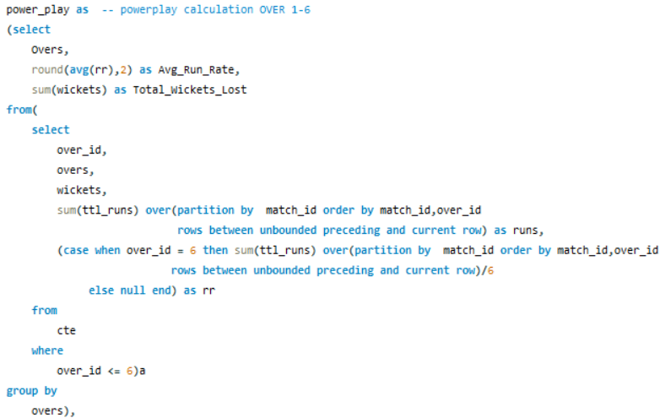

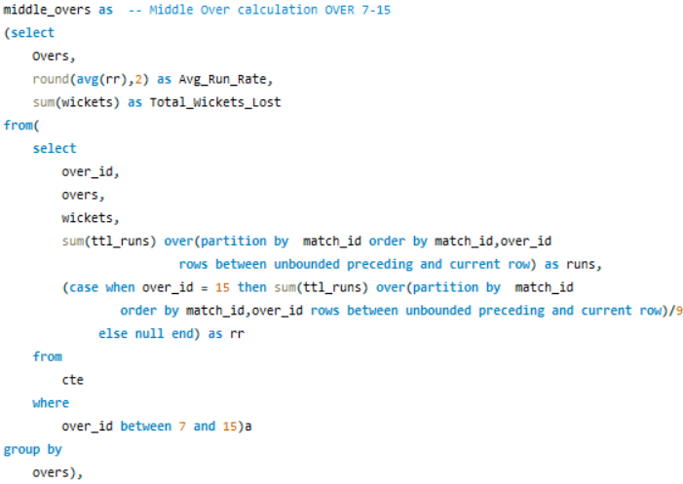

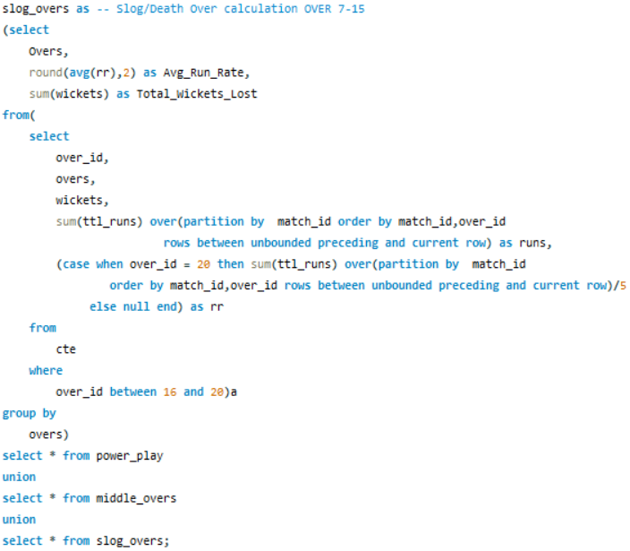

**Result:**

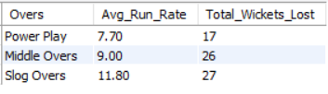

RCB’s **powerplay** performance shows a clear **weakness**, with a significantly **low scoring rate** compared to later stages of the innings. Although they lose fewer wickets than expected in this phase, the lack of early runs restricts momentum and **pressures** the middle order. To address this, it’s crucial to target **aggressive top-order** batsmen who maintain **high strike rates** and solid averages. These players can fully utilize field restrictions without compromising stability. Improving early innings output sets the tone and gives strategic control. **Strengthening** this phase can lead to more competitive totals or smoother chases. **Investing** in explosive, reliable batters is **key** to reshaping their **powerplay approach**.

**Query: Batting parameter**

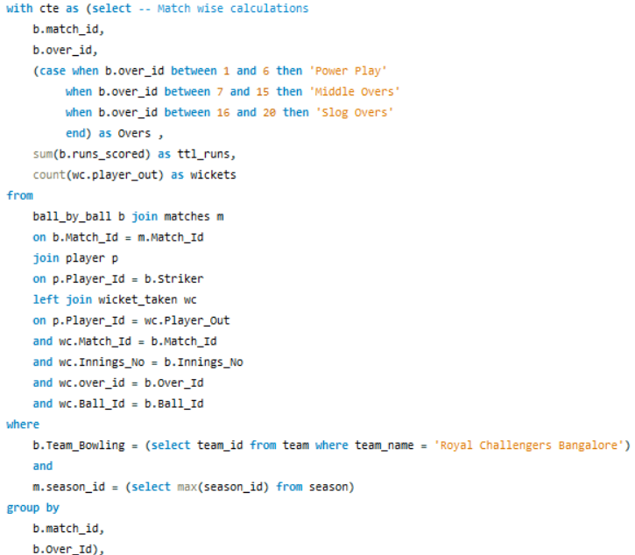

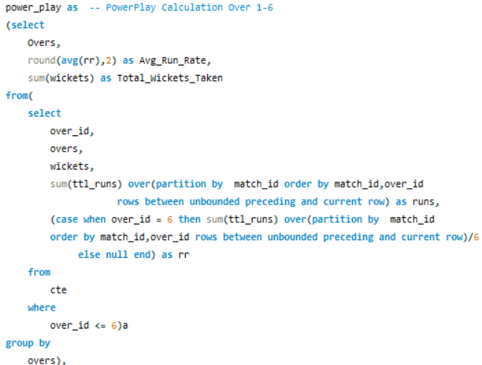 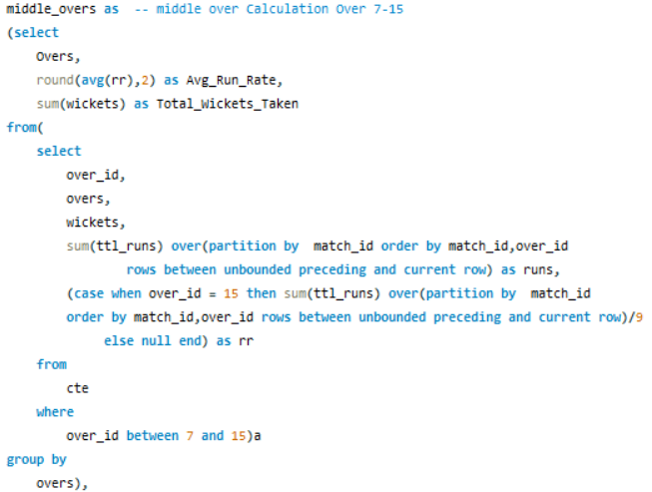

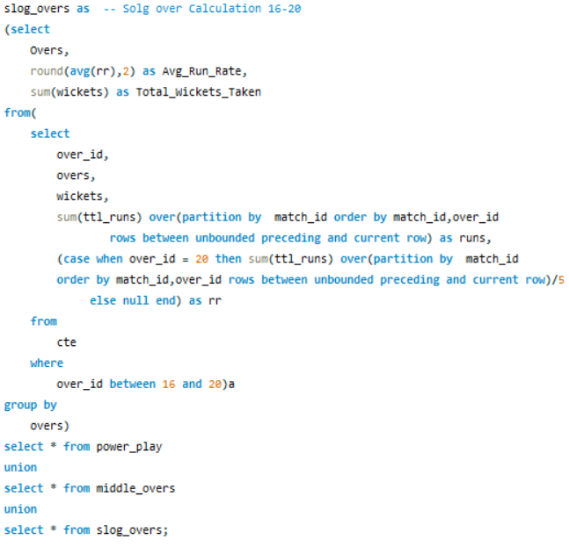

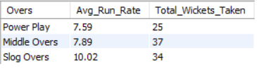 **Result:**

RCB’s performance in the **death overs** is a major **concern**, with the team conceding **10.02** runs per over an alarmingly high rate that negatively affects match outcomes. To counter this, **selecting** skilled **death-over special**ists who combine wicket-taking ability with run control is essential. At the same time, improving efficiency in the **powerplay** is equally critical. Targeting bowlers who can restrict opponents to under 7 runs per over during the first six overs will help gain early momentum. Early wickets during this phase can destabilize opposition batting line-ups. Strengthening both ends of the innings creates a more **balanced bowling attack**. This dual-focus strategy could significantly improve RCB’s chances in future matches.

1. All-rounders unlock tactical options, allowing flexible line-ups and dynamic responses based on game situations and venue conditions.

**Approach:**

* **Tables:** Performed joins across the Player, Ball_by_ball, wicket_taken, Matches and custom CTE to extract the desired outcome.
* **Strategy:** 
  + Summarizingthe average runs scored and total wickets taken by each player
  + To ensure statistical reliability, the analysis includes only players who have played more than 30 matches, filtering out outliers with minimal appearances.
  + Identifying top-performing players by filtering those who have a batting average exceeding 17 and have taken more than 20 wickets.
* **Final Result:** Showcasing potential allrounders to consider which is aligned with team needs for the upcoming auction.

**Query:**

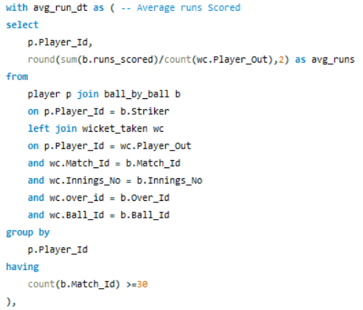 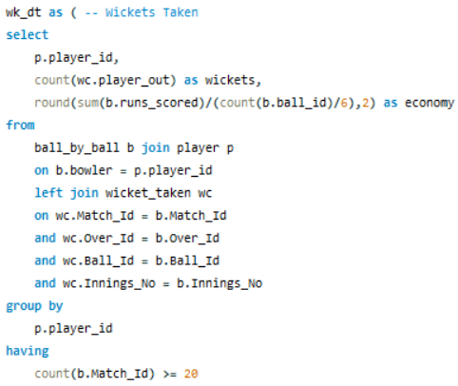

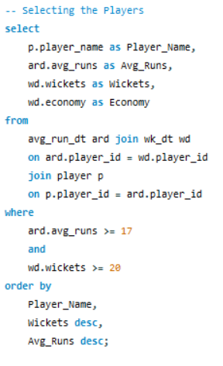 **Result:**

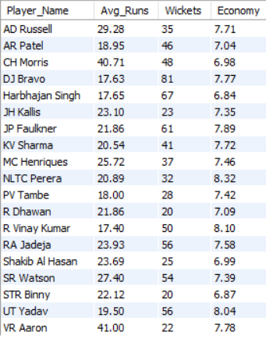

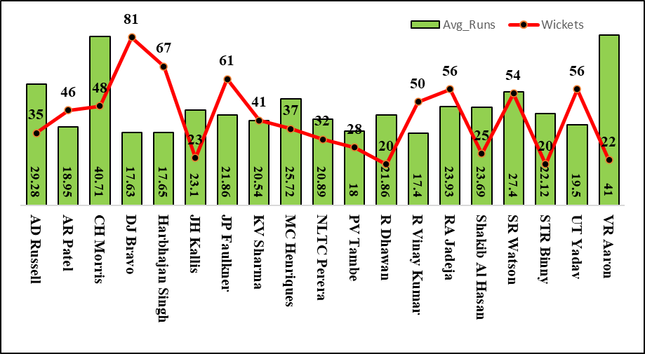

The shortlisted players demonstrate valuable versatility, showcasing the ability to make impactful contributions with both bat and ball, strengthening team balance and tactical flexibility across match scenarios.

1. Team morale and overall performance often hinge on players who consistently lead by example on the field. To pinpoint such high-impact individuals, this analysis focuses on recipients of marquee recognitions such as **Man of the Match**, **Man of the Series**, and **Orange/Purple Cap winners**.

These players not only deliver match-defining performances but also elevate team confidence through their presence, experience, and ability to turn games in critical moments. Their influence goes beyond statistics, often shaping outcomes and inspiring those around them.

**Approach:**

* **Tables:** Performed joins across the Player, Matches and seasons Tables to extract the desired outcome.
* **Strategy:**
  + Analyse the **total number of Man of the Match awards** secured by individual players and shortlist the top 10 performers based on award count.
  + Evaluate each player’s **Man of the Series accolades** to identify consistent high-impact contributors across tournaments.
  + Identify winners of the **Orange Cap** and **Purple Cap** to highlight top-tier performers in batting and bowling, respectively.
* **Final Result:** Showcasing potential players whose presence positively influences the morale and performance of the team.

**Query: Result:**

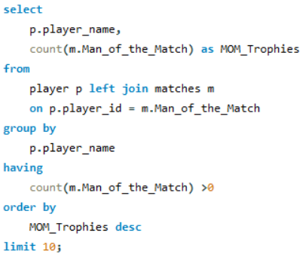**Man of the Matches**

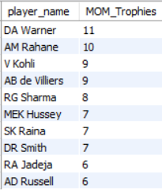

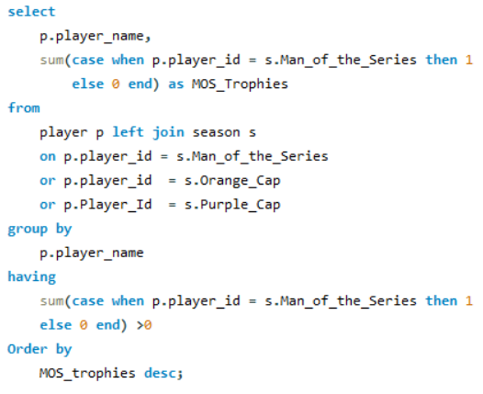**Man of the Series**

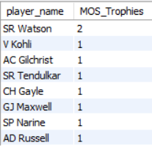

**Orange Cap Winner**

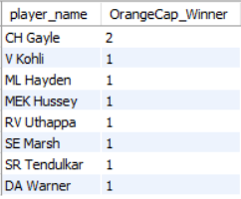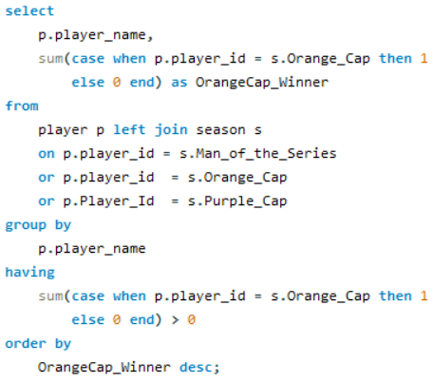

**Purple Cap Winner**

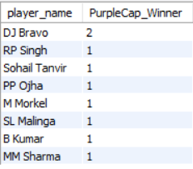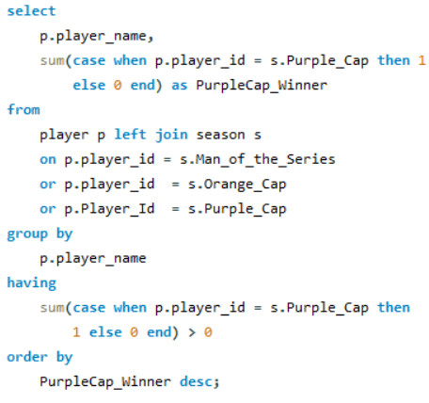

**Visualisation**

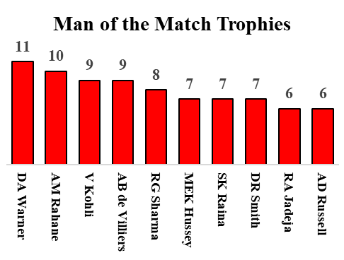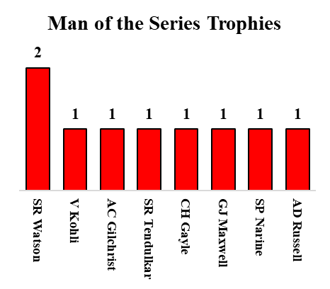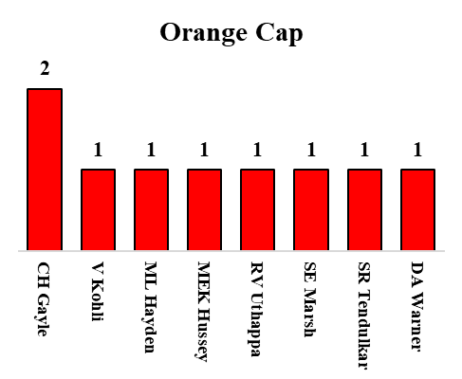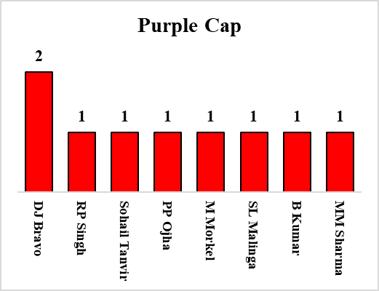

The visualization clearly highlights a group of match-winning players who consistently contribute to their team's success. Notably, names like V. Kohli, D.A. Warner, S.R. Tendulkar, C.H. Gayle, and A.D. Russell appear repeatedly across different metrics, showcasing their sustained impact throughout the season and across multiple matches. These standout performers not only influence game outcomes but also play a vital role in elevating team morale. Including such high-calibre individuals can significantly enhance overall team performance and foster a confident, winning environment for the entire squad.

1. With the mega auction offering a fresh opportunity to restructure and reinforce, RCB must take a data-driven and role-balanced approach to squad building.

Addressing past performance gaps especially in the powerplay and death overs while strengthening core leadership, versatility, and match-finishing roles will be crucial. This segment outlines key priorities and tactical moves to help RCB craft a tournament-winning suggestions

* 1. **Prioritize High-Strike-Rate Openers for a Strong Start**

RCB’s analysis shows a sluggish powerplay scoring rate that hampers momentum and burdens the middle order. To overcome this, the team must target aggressive openers with strike rates above 130 who can fully exploit field restrictions. A brisk start lifts the run rate and forces the opposition onto the back foot. Pairing such batsmen with solid averages offers pace without sacrificing stability. Investing in explosive top-order talent could transform RCB’s campaign trajectory.

* 1. **Target versatile All-Rounders for Dual Impact**

RCB’s path to building a resilient and adaptive squad lies in selecting multi-skilled players who contribute meaningfully with both bat and ball. These all-rounders enhance team balance, allowing deeper batting line-ups and flexible bowling combinations. From previous analyses, such players have proven pivotal in turning matches around, offering stability in collapses and breakthroughs during tight bowling spells. Their dual-role capacity reduces dependence on specialists and adds valuable depth across phases of the game. Whether chasing steep targets or defending totals, they bring tactical agility to the team. Investing in versatile performers ensures that RCB remains dynamic and competitive across varied match scenarios**.**

* 1. **Sharpen Bowling Strategies in Powerplay and Death Overs**

RCB’s bowling analysis shows vulnerabilities at both ends of the innings—conceding excessive runs in the death overs and lacking penetration in the powerplay. To fix this, the team must scout specialists who combine economy with wicket-taking in high-pressure phases. Early breakthroughs during the powerplay disrupt opposition momentum, while tight spells at the death seal match outcomes. Strengthening these zones creates better control over run flow and keeps the team in command across all stages. Prioritizing these bowling assets will be vital in shaping a winning auction strategy.

* 1. **Prioritize Players Who Elevate Team Spirit and Performance**

Prioritize winning players as mentioned in the previous analysis who consistently boost morale through match-winning performances and strong leadership presence. Their repeated appearances across accolades suggest a sustained positive impact on team dynamics and belief. Such individuals often act as momentum catalysts, energizing peers and lifting performance under pressure. Including them strengthens not just skill depth but emotional resilience in the squad. RCB should prioritize retaining or acquiring these influencers to foster a winning culture

1. Flat pitches, smaller boundaries, and aggressive batting have turned high scores into the norm, reshaping match dynamics. These run-fests boost fan engagement, drive viewership, and influence team strategies toward power-packed line-ups. Teams now prioritize batting depth and versatile bowling to stay competitive in this evolving format.

**Approach:**

* **Join Tables:** Performed joins across the ball_by_ball, wicket_taken and custom CTE Tables to extract the desired outcome.
* **Strategy:**
  + Summarize the total matches played, cumulative runs scored, and average runs per match across different venues to identify high-scoring grounds that correlate with elevated fan interest and entertainment value.
* **Final Result:** Showcasing potential venues which contribute to high scoring games.

**Query:**

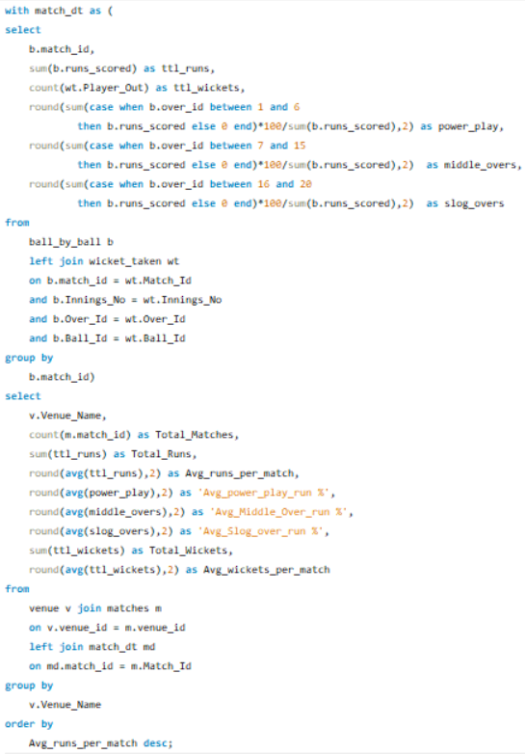

**Result:**

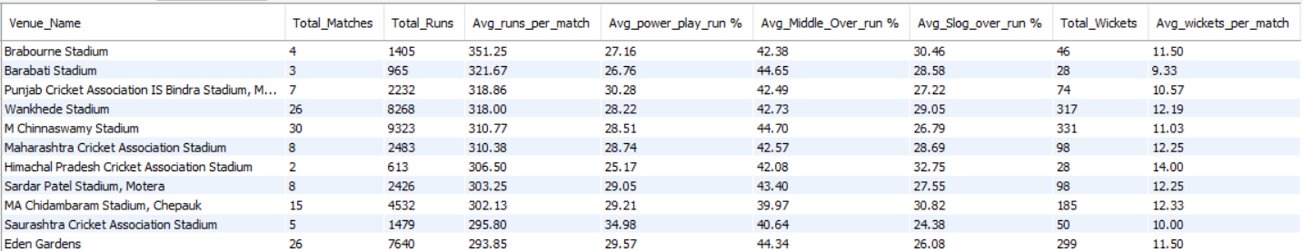

* Factors Behind High-Scoring Matches and Their Impact
  + The analysis indicates that high-scoring games are strongly influenced by pitch conditions and boundary dimensions. Flat pitches tend to favour batsmen, enabling free scoring and bigger totals. Similarly, venues with shorter boundaries promote aggressive shot-making and more frequent sixes. These factors collectively elevate the entertainment quotient, drawing higher viewership and boosting fan engagement throughout the match.
  + Low-total matches often bring unexpected tension, where every run and wicket swings the balance. Bowlers dominate, making economical spells and dot balls match-defining. Fielding efforts become magnified, turning saves and run-outs into momentum shifters. As pressure builds, even modest chases feel monumental and nerve-wracking. These contests prove that thrill isn’t always tied to big scores.
  + When games go down to the last six balls, adrenaline and strategy take centre stage. Death-over specialists and explosive finishers are tested under extreme pressure. Each delivery carries weight be it a yorker, a six, or a tactical single. The tension grips players and fans alike, creating unforgettable moments. Final-over thrillers fuel the drama that makes cricket irresistibly entertaining.

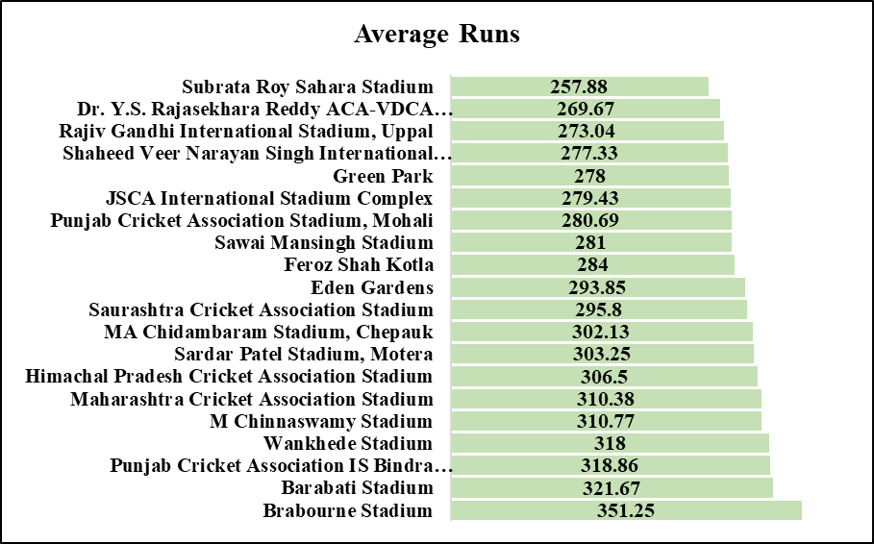

**The chart breaks down how scoring trends vary by stadium, showcasing average runs per match**

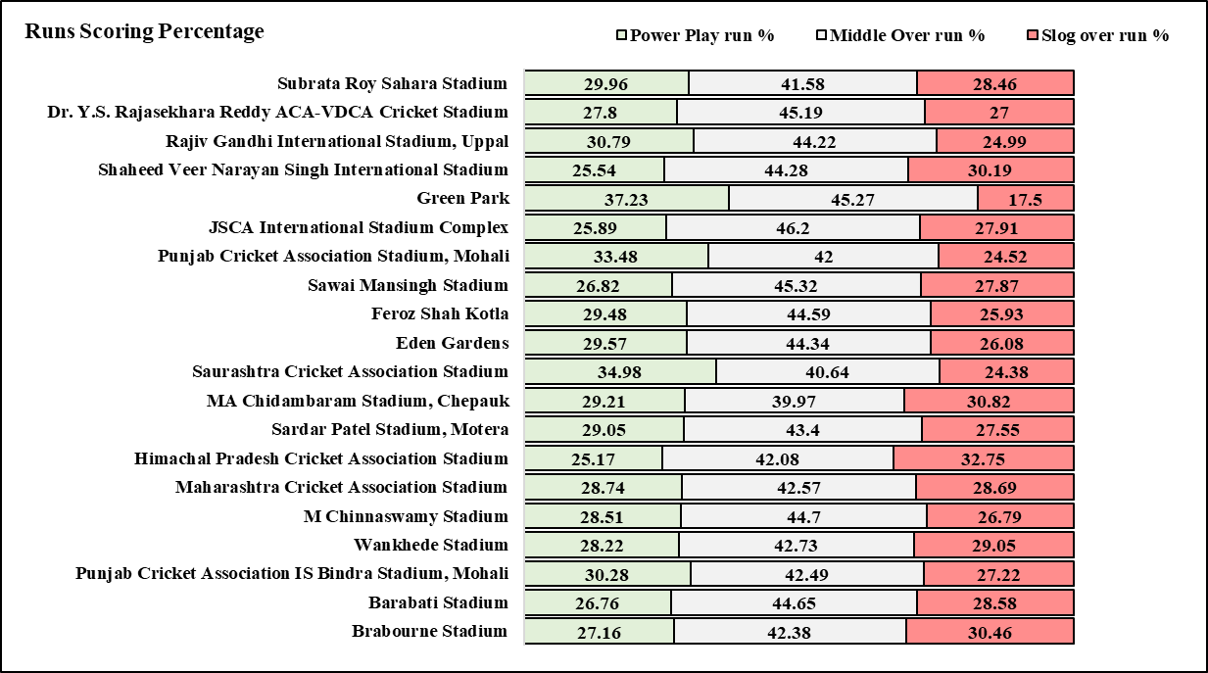

**The chart breaks down how scoring trends vary by stadium, showcasing average runs scored percentage in each session per match**

1. Teams often perform better at home due to pitch familiarity, local weather patterns, and crowd support. The comfort of known conditions boosts confidence and sharpens tactical execution. Historical data shows win rates typically rise in home venues, making it a crucial strategic factor.

**Approach:**

* **Tables:** Performed joins across the team, matches, venue, city, country and custom CTE Tables to extract the desired outcome.
* **Filtering records:** Considering only stadiums in India.
* **Strategy:**
  + Summarize each team’s home performance with total matches played, win percentage, loss percentage, toss wins, and toss losses to evaluate overall performance trends and strategic consistency.
  + Presenting each team’s match and toss statistics alongside their away performance data to enable clearer comparison and contextual evaluation.
* **Final Result:** Showcasing performance at Home and Away conditions.

**Query: Comparison of home and away statistics of the entire data.**

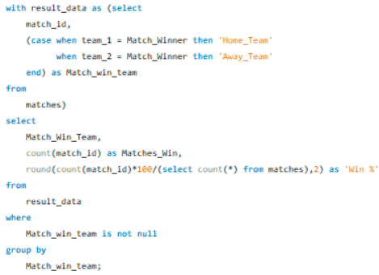

**Result:**

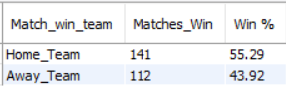

The data clearly highlights a strong home-ground advantage, with home teams securing victories in over 55% of their matches. In contrast, visiting sides have managed wins just 43% of the time, underscoring the impact of local familiarity and crowd support. These figures reaffirm the strategic edge that home conditions offer in competitive match environments.

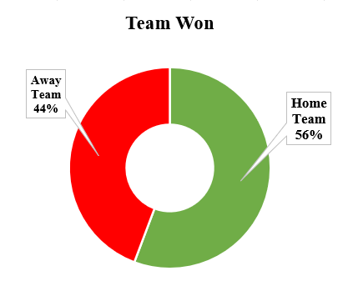

**Query: Ground Statistics for each team**

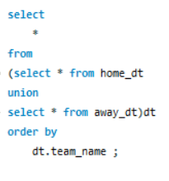 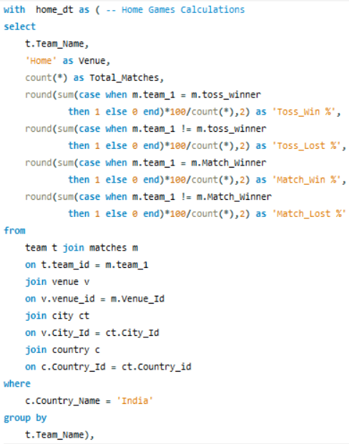 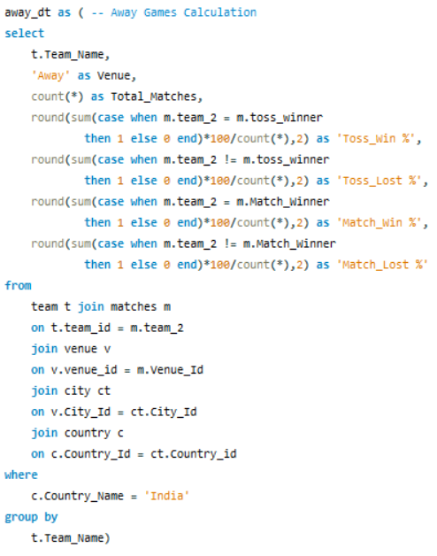

**Result:**

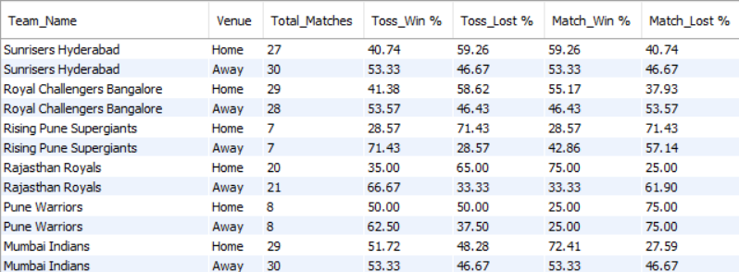

* The analysis shows that RCB has secured only 55% of their home wins, highlighting room for improvement in capitalizing on home-ground advantage. Winning the toss becomes crucial, especially at M. Chinnaswamy Stadium, which favours chasing due to shorter boundaries and dew-friendly evening conditions.
* Leveraging top performers like Kohli, Gayle, and de Villiers whose records at this venue are exceptional, can add consistency to the batting lineup. These players must be strategically deployed to maximize scoring efficiency.
* On the bowling front, Y Chahal, the venue’s leading wicket-taker, should be entrusted with well-defined plans to take key wickets at pressure moments. Aligning toss tactics with player specialization can significantly uplift RCB’s success rate at home.

1. Despite strong individual performances, RCB has struggled with inconsistency in execution during crunch phases. Frequent batting collapses, unsteady death bowling, and tactical missteps have derailed promising campaigns.

**Approach:**

* **Tables:** Performed joins across the team, matches, venue, Toss_decision and custom CTE Tables to extract the desired outcome.
* **Filtering records:** Considering only stadiums in India and Foe Royal Challengers Bengaluru Team.
* **Strategy:**
  + **Season-wise performance analysis** to track the team’s progression or regression in standings across different IPL editions.
  + **Venue-based win-loss percentage evaluation** to identify underperforming locations and guide strategic improvements for upcoming seasons.
  + **Innings dynamics comparison**, focusing on chasing versus defending scenarios, to pinpoint strengths, weaknesses, and key areas for tactical refinement in future matches.
* **Final Result:** Showcasing performance of Royal Challengers Bengaluru.

**Query: Season-wise performance analysis**

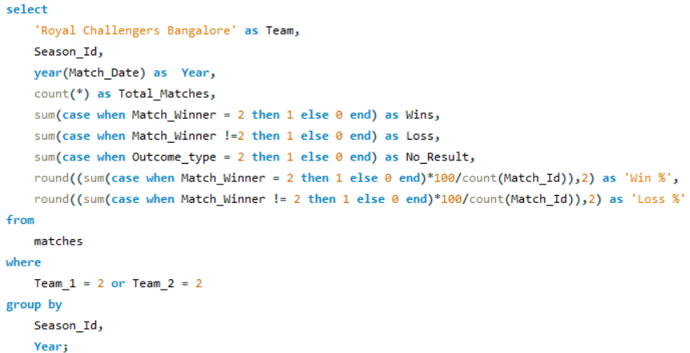

**Result:**

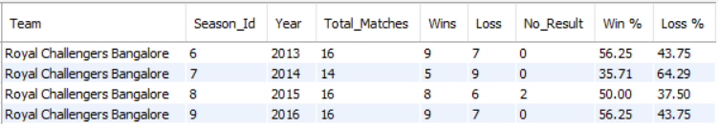

* Based on the data, Royal Challengers Bangalore’s standout seasons were Season 6 (2013) and Season 9 (2016).
* While their overall performance in other editions can be considered satisfactory, Season 7 (2014) was notably their weakest, with a victory rate of just 35%.
* Despite the relative success in Seasons 6 and 9, the winning percentage of 56.25% falls short of the benchmark required for true dominance.
* For RCB to establish themselves as title contenders and command dominance over the other teams, they must aim for a win rate of 70% or higher in future seasons.

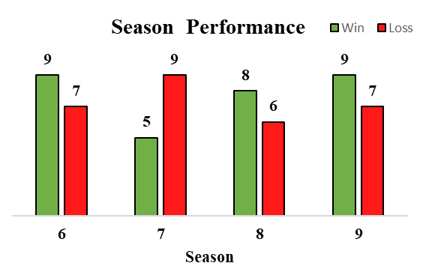

**Query: Venue Wise comparison**

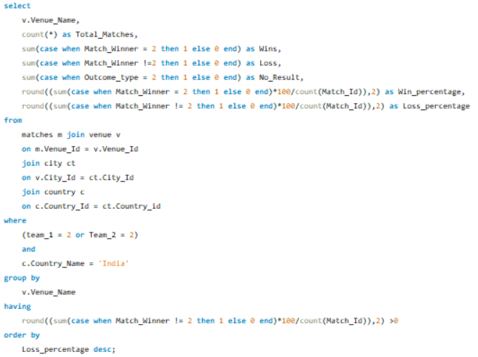

**Result:**

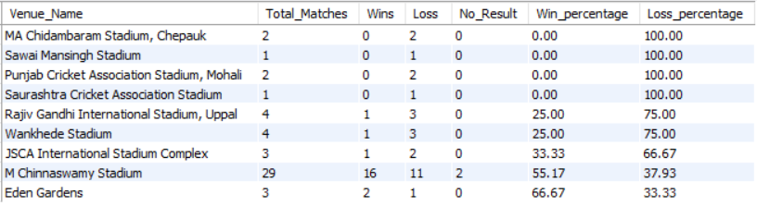

* The data reveals that Royal Challengers Bangalore have struggled significantly in away matches, particularly outside their home ground, M. Chinnaswamy Stadium.
* Venues such as Chepauk, Sawai Mansingh Stadium, Mohali, and Saurashtra Cricket Association Stadium have posed major challenges, with RCB failing to register a single win at these locations.
* While they’ve secured marginal victories at Eden Gardens overall away performance remains a weak link.
* Consistently winning matches on unfamiliar pitches is crucial to securing tournament success.
* Hence, tailoring team combinations to suit pitch conditions is not just strategic, it may well be a determining factor behind RCB's elusive quest for their first IPL title

**Query: Innings Dynamics**

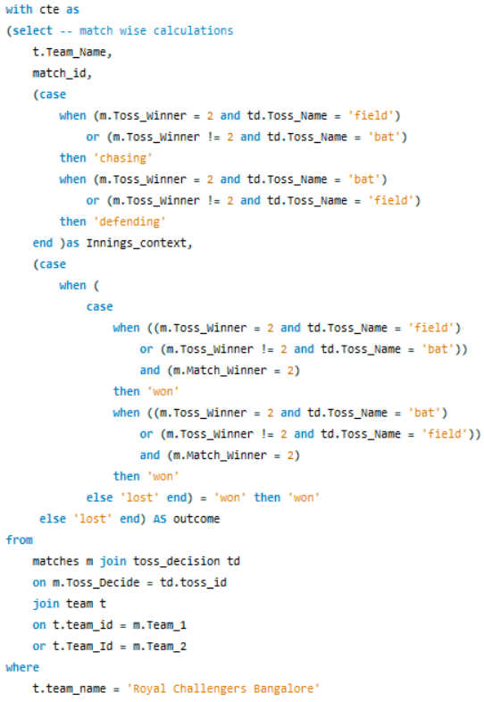 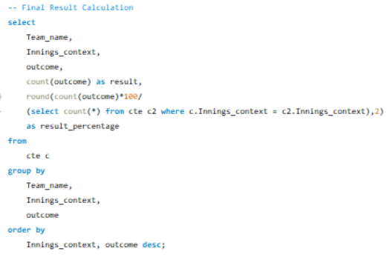

**Result:**

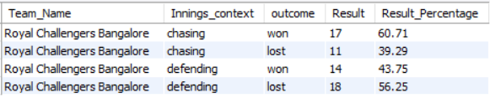

* Out of the 60 result-oriented matches played by Royal Challengers Bangalore, 28 were while chasing and 32 while defending a total. Of the 28 chasing encounters, RCB emerged victorious in 17, indicating a win rate of 60%. To truly establish dominance, this percentage needs to edge closer to the 75% mark.
* On the defending front, RCB suffered 18 losses out of 32 matches, reflecting a concerning 56% failure rate. This highlights vulnerabilities in both their bowling attack and potentially their batting unit, especially in matches where the total was insufficient.
* Enhancing the team’s bowling depth and strengthening the batting order particularly for pressure situations could be crucial for converting defeats into wins. Addressing these areas may well be the key to RCB finally securing an IPL title

1. **Strategic Framework for RCB Team Performance Analysis**

* **Dataset Familiarization**
  + Thoroughly explore the IPL dataset to understand its structure, relationships between tables, and key attributes like players, teams, venues, and match outcomes.
  + Identify relevant metrics for performance analysis like wins, losses, player statistics, and venue-specific trends.
* **Define Analytical Objectives**
  + Centre analysis on team progressions, player impact, match outcomes, and season trends.
* **Team Performance Evaluation**
  + Compare win/loss ratios across seasons to assess tournament progress and consistency.
  + Include home vs. away performance breakdowns to reveal environmental strengths and challenges.
* **Venue-Wise Strategy Insights**
  + Measure win and loss percentages across venues to identify locations where the team consistently underperforms.
  + Highlight critical grounds needing improvement and correlate pitch conditions with team combinations.
* **Innings Dynamics Analysis**
  + Analyse chasing vs. defending scenarios to detect strategic strengths and weaknesses.
  + Assess win percentages under each dynamic to refine future match tactics.
* **Player-Level Performance Breakdown**
  + Examine batting averages, bowling economies, and strike rates to spotlight key contributors and all-rounders.
  + Identify players thriving in high-pressure situations like death overs or knockout games.
* **Pattern Recognition in Match Outcomes**
  + Uncover consistent match patterns involving toss decisions, batting order, and venue impact.
  + Use these trends to understand the hidden triggers behind victories or defeats.
* **Visual Representation of Insights**
  + Leverage visualisation tools to transform data into compelling visuals.
  + Plot trends for seasonal progress, individual achievements, and venue comparisons.
* **Actionable Recommendations**
  + Suggest optimal squad compositions and tactical refinements for performance elevation.
  + Emphasize match winning strategies and target rate to build consistent title contention.

1. To ensure accuracy in team nomenclature and maintain consistency across historical IPL records, it's essential to rectify mislabelled entries in the database. In this case, we’ll correct all instances of Delhi Capitals to Delhi Daredevils within the Opponent Team column of the Match table, reflecting the appropriate team identity for seasons prior to the rebranding.

**Approach**

* To modify existing records within a table, we utilize the **UPDATE** command which is a core part of Data Manipulation Language (DML) to accurately change field values, such as correcting team names.

**Query:**

